Name: Nur Ahammad

ID: 1121520011

BBA Program

Batch: 52

Semester: Summer 2024

Course Code: MIS-435

Course Title: Management Information System Course

**Answer All Questions**

1. Illustrate Dimension of Information System With a Proper Diagram.

2. Discuss About Business Value Chain Model.

3. Illustrate Transaction Processing System With a Proper Diagram.

4. Illustrate Decision Support System With a Proper Diagram.

5. What's New In MIS?

**Answer to the question no. 1**

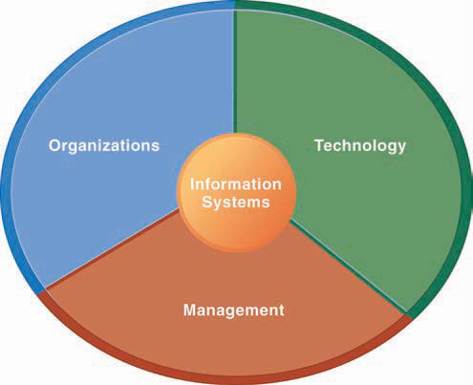

**Diagram**: dimensions of an information system

When discussing dimensions such as organization, technology, and management in the context of an information system, each dimension plays a crucial role in how the system is designed, implemented, and maintained. Here's an explanation of each dimension:

**1. Organization**

**Description:**

* **Structure and Processes:** Refers to how an organization is structured and how its processes are organized. This includes organizational hierarchies, roles, and responsibilities.
* **Culture and Policies:** Involves the culture, policies, and practices that influence how information systems are used within the organization.

**Role in Information Systems:**

* **Alignment:** Information systems need to align with the organizational structure and processes to be effective. For example, an information system should support the workflow and communication needs of different departments.
* **Integration:** Ensures that the system integrates smoothly with existing organizational processes and can adapt to changes in organizational structure or policies.

**2. Technology**

**Description:**

* **Hardware:** Includes physical components like servers, computers, networking equipment, and peripherals.
* **Software:** Encompasses the applications, operating systems, and utilities used by the organization.
* **Networks:** Covers the communication infrastructure, including internet, intranet, and other networking solutions.

**Role in Information Systems:**

* **Infrastructure:** Provides the technical foundation for the information system, including hardware and software.
* **Support and Innovation:** Ensures that the technology used is up-to-date and capable of supporting current and future organizational needs. This includes maintaining, upgrading, and innovating technology as required.

**3. Management**

**Description:**

* **Planning and Strategy:** Involves developing strategies for the implementation and use of information systems. This includes setting goals, planning projects, and allocating resources.
* **Governance and Control:** Refers to the oversight and control mechanisms in place to ensure that information systems are managed effectively, including risk management, compliance, and performance monitoring.

**Role in Information Systems:**

* **Implementation:** Oversees the deployment of information systems, ensuring they meet organizational objectives and are implemented within budget and on time.
* **Maintenance and Support:** Manages ongoing support and maintenance of the information system to ensure its continuous operation and to address any issues that arise.
* **Evaluation and Improvement:** Continuously assesses the performance of the information system and makes improvements based on feedback and changing needs.

**Answer to the question no. 2**

The Business Value Chain Model, developed by Michael Porter, is a strategic framework used to analyze and optimize the activities that create value for a company’s customers. This model breaks down a company's operations into primary and support activities, showing how each contributes to competitive advantage and value creation.

**Primary Activities**

These are directly involved in producing and delivering products or services. They include:

1. **Inbound Logistics**: This involves the processes related to receiving, warehousing, and managing raw materials and inventory. Effective inbound logistics ensure that materials are available for production without excess costs or delays.
2. **Operations**: This refers to the activities that transform raw materials into finished products or services. It includes manufacturing, assembly, and quality control. Efficient operations are crucial for producing high-quality products at competitive costs.
3. **Outbound Logistics**: This covers the distribution of finished products to customers. It includes warehousing, order fulfillment, and transportation. Well-managed outbound logistics ensure that products are delivered to customers efficiently and on time.
4. **Marketing and Sales**: These activities are focused on promoting and selling products or services. This includes market research, advertising, sales strategies, and pricing. Effective marketing and sales strategies help attract and retain customers, driving revenue growth.
5. **Service**: This includes post-sale support and services such as customer support, repairs, and warranty services. Providing excellent service enhances customer satisfaction and loyalty, adding value beyond the initial sale.

**Support Activities**

Support activities facilitate and enhance the effectiveness of primary activities. They include:

1. **Firm Infrastructure**: This encompasses the company’s general management, planning, administration, and financial management. Strong infrastructure supports efficient operations and strategic decision-making.
2. **Human Resource Management**: This involves recruiting, training, developing, and compensating employees. Effective human resource management ensures that the company has the skilled workforce needed to execute primary activities and drive organizational success.
3. **Technology Development**: This includes research and development, innovation, and technology management. Investments in technology can lead to new product development, process improvements, and competitive advantages through enhanced capabilities and efficiencies.
4. **Procurement**: This refers to the processes involved in acquiring raw materials, equipment, and supplies. Efficient procurement strategies ensure that the company obtains the necessary resources at the best possible terms, supporting cost control and production quality.

**Application of the Value Chain Model**

1. **Identifying Value Drivers**: By analyzing each activity within the value chain, companies can identify which activities add the most value to their products or services and focus on enhancing these areas.
2. **Improving Efficiency**: The model helps companies pinpoint inefficiencies and areas for improvement, allowing them to streamline operations and reduce costs.
3. **Gaining Competitive Advantage**: Optimizing the value chain can help companies differentiate themselves from competitors through superior product quality, better customer service, or lower costs.
4. **Aligning with Strategy**: The value chain model ensures that all activities are aligned with the company’s strategic goals, contributing to overall competitive advantage and success.

By understanding and optimizing the value chain, companies can enhance their operational efficiency, improve customer satisfaction, and achieve a sustainable competitive advantage in the marketplace.

**Answer to the question no. 3**

**A Transaction Processing System (TPS)** is designed to handle and process transactions efficiently and accurately. It involves capturing, processing, and storing transaction data, ensuring that business operations run smoothly. Here’s a conceptual diagram of a typical TPS:

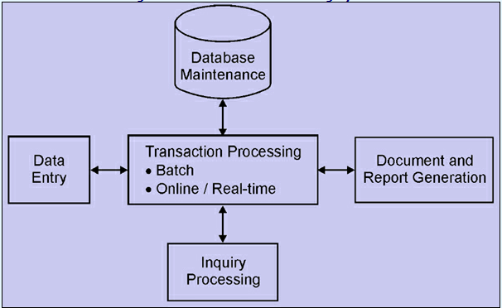

**Components of a Transaction Processing System**

1. **Data Entry/Input**:
   * **Source Data**: The initial data that enters the system, often captured from various sources such as point-of-sale terminals, online forms, or input devices. This data typically includes transaction details like purchase amounts, customer information, and payment methods.
2. **Transaction Processing**:
   * **Validation**: Ensures that the input data is accurate and complete. For instance, it checks for data consistency and adherence to predefined rules.
   * **Calculation**: Performs necessary computations, such as total amounts or taxes, based on the transaction data.
   * **Update**: Modifies the database to reflect the new transaction information, such as updating inventory levels or customer account balances.
3. **Database**:
   * **Data Storage**: Where transaction data is stored. This includes maintaining records of all transactions, such as sales, purchases, and financial activities. The database ensures that data is securely stored and can be retrieved for reporting or audit purposes.
4. **Output Reports**:
   * **Receipts, Statements, and Confirmations**: Provides the results of the transaction process to the users. This includes transaction receipts for customers, account statements for users, and confirmation messages.
5. **Output/Display**:
   * **Transaction Confirmation**: Displays or prints the result of the transaction process. This might include transaction confirmations for users or system-generated reports.

**Process Flow**

1. **Data Input**: Transaction details are captured from various sources and entered into the system.
2. **Transaction Processing**: The system validates, calculates, and updates the transaction information.
3. **Database Update**: The processed transaction data is stored in the database.
4. **Output Generation**: Reports, receipts, or confirmations are generated and provided to users.

**Answer to the question no. 4**

A Decision Support System (DSS) is designed to help decision-makers analyze data and make informed decisions. It combines data from various sources, provides analytical tools, and generates insights to support decision-making processes. Here’s a conceptual diagram of a typical DSS:

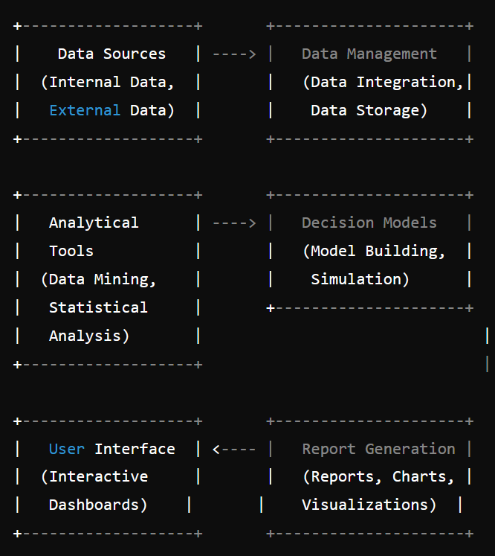

Diagram: typical DSS

**Components of a Decision Support System**

1. **Data Sources**:
   * **Internal Data**: Information from within the organization, such as sales data, financial records, and operational metrics.
   * **External Data**: Data from outside the organization, such as market trends, competitor information, and industry reports.
2. **Data Management**:
   * **Data Integration**: Combining data from various sources into a cohesive format for analysis.
   * **Data Storage**: Storing data in databases or data warehouses for easy access and retrieval.
3. **Analytical Tools**:
   * **Data Mining**: Techniques used to discover patterns and relationships in large datasets.
   * **Statistical Analysis**: Methods used to analyze data and interpret statistical results.
   * **Other Analytical Methods**: Tools for forecasting, optimization, and scenario analysis.
4. **Decision Models**:
   * **Model Building**: Creating models that simulate different scenarios and outcomes.
   * **Simulation**: Running simulations to assess the impact of various decisions and strategies.
5. **Report Generation**:
   * **Reports**: Generating detailed reports that summarize findings and insights.
   * **Charts and Visualizations**: Providing graphical representations of data to make it easier to understand and interpret.
6. **User Interface**:
   * **Interactive Dashboards**: Providing a user-friendly interface for accessing and interacting with the data and analytical tools.
   * **Decision Support Interface**: Allows users to query data, run analyses, and view results in an intuitive manner.

**Process Flow**

1. **Data Collection**: Gather data from internal and external sources.
2. **Data Management**: Integrate and store the data for analysis.
3. **Analysis**: Use analytical tools to process and examine the data.
4. **Modeling and Simulation**: Build and run decision models to explore different scenarios.
5. **Reporting**: Generate reports and visualizations to present the findings.
6. **Decision Making**: Use the insights gained to make informed decisions.

**Purpose and Benefits**

* **Improved Decision Making**: Provides valuable insights and analysis to support complex decision-making processes.
* **Enhanced Analysis**: Enables detailed data analysis and scenario modeling.
* **Timeliness**: Facilitates timely decision-making by providing up-to-date information and analysis.
* **Flexibility**: Allows decision-makers to explore different scenarios and outcomes before making a final decision.

This model illustrates how a DSS integrates data, analytical tools, and user interfaces to support and enhance decision-making processes.

**Answer to the question no. 5**

Management Information Systems (MIS) continues to evolve with advancements in technology and changes in business needs. Here are some of the latest trends and developments in MIS:

**1. Artificial Intelligence (AI) and Machine Learning (ML)**

* **Predictive Analytics**: AI and ML are increasingly used for predictive analytics, helping organizations forecast trends, customer behavior, and potential risks.
* **Automation**: AI-driven automation is streamlining routine tasks, improving efficiency, and reducing manual errors.
* **Natural Language Processing (NLP)**: Enhances interaction with MIS through voice commands and chatbots, making data retrieval and interaction more intuitive.

**2. Big Data and Advanced Analytics**

* **Data Lakes**: Organizations are using data lakes to store vast amounts of structured and unstructured data, enabling more comprehensive analysis.
* **Real-Time Analytics**: Technologies like Apache Kafka and stream processing frameworks allow for real-time data analysis, providing immediate insights and enabling quick decision-making.
* **Enhanced Data Visualization**: Advanced visualization tools are improving the way data is represented, making complex data sets easier to understand.

**3. Cloud Computing**

* **Scalability and Flexibility**: Cloud-based MIS solutions offer scalable resources and flexible deployment options, reducing the need for on-premises infrastructure.
* **Cloud-Based Analytics**: Cloud platforms provide powerful analytics capabilities with the advantage of accessible, on-demand computing resources.
* **Hybrid and Multi-Cloud Environments**: Many organizations are adopting hybrid and multi-cloud strategies to optimize performance, cost, and data security.

**4. Internet of Things (IoT)**

* **IoT Integration**: MIS systems are integrating with IoT devices to collect and analyze data from connected devices, sensors, and machines.
* **Enhanced Monitoring**: IoT data helps in monitoring operations in real-time, improving decision-making, and predicting maintenance needs.

**5. Blockchain Technology**

* **Data Security**: Blockchain provides enhanced security and transparency for transactions, ensuring data integrity and reducing fraud.
* **Smart Contracts**: Automated execution of contracts and agreements based on predefined rules, reducing the need for intermediaries and increasing efficiency.

**6. Cybersecurity and Privacy**

* **Advanced Threat Detection**: New technologies in cybersecurity, such as AI-driven threat detection and response, are improving the ability to protect sensitive information.
* **Privacy Regulations**: Compliance with privacy regulations like GDPR and CCPA is driving the development of systems that ensure data protection and privacy.

**7. Business Intelligence (BI) Integration**

* **Self-Service BI**: Tools are evolving to allow non-technical users to create their own reports and analyses, promoting a data-driven culture.
* **Integrated BI Platforms**: More comprehensive BI solutions are integrating with other enterprise systems to provide a unified view of business performance.

**8. Enhanced User Experience**

* **User-Centric Design**: Focus on improving the user experience with intuitive interfaces and customizable dashboards to increase user engagement and satisfaction.
* **Mobile Access**: Increasing emphasis on mobile-friendly MIS solutions that allow users to access information and make decisions on the go.

**9. Collaborative Technologies**

* **Integration with Collaboration Tools**: MIS systems are integrating with collaboration platforms like Slack, Microsoft Teams, and Zoom to facilitate communication and decision-making.

**10. Sustainability and Green IT**

* **Eco-Friendly Solutions**: Adoption of green IT practices, such as energy-efficient data centers and sustainable technology, is becoming more prevalent.

These developments reflect a shift towards more intelligent, integrated, and user-friendly systems that leverage cutting-edge technologies to enhance decision-making, improve efficiency, and drive business growth.