**Name: Nur Ahammad**

**Subject:** MKT 330

**Batch No: BBA 52**

**ID NO: 1121520011**

**Answer All-**

1. Explain how the strategic planning carried out at the corporate and divisional levels.

2. If you are facing the necessity to purchase a new vehicle then discuss the buying decision process of this necessity.

3. Is the consumer's buying behavior can be influenced? If yes, then describe how.

4. Define the following terms with example.

a) Holistic marketing philosophy. b) Customer-Perceived value.

**Ans to the question no. 1:**

At the corporate level, strategic planning involves setting overall goals and objectives for the entire organization. This includes defining the company's mission, vision, and values. Corporate leaders assess the external business environment, such as market trends, competition, and regulatory factors, to identify opportunities and threats.

Once the corporate strategy is established, it's broken down into actionable plans for each division or business unit. At the divisional level, strategic planning becomes more focused on the specific needs and challenges of each unit. Divisional leaders align their strategies with the overall corporate strategy, considering how their unit contributes to the organization's success.

The process often includes:

1. **Environmental Analysis:** Understanding the external and internal factors affecting the division's performance.
2. **Goal Setting:** Defining specific, measurable, achievable, relevant, and time-bound (SMART) goals aligned with the corporate strategy.
3. **Resource Allocation:** Determining the resources (financial, human, technological) needed to achieve the divisional goals.
4. **Action Plans:** Developing detailed plans outlining the steps and initiatives required to meet the set objectives.
5. **Monitoring and Evaluation:** Regularly assessing progress, adjusting plans as needed, and ensuring alignment with the corporate strategy.

Communication is key throughout this process to ensure that everyone within the organization understands the strategic direction and is working cohesively towards common goals. The corporate and divisional levels complement each other in creating a unified and effective strategic plan for the entire organization.

**Ans to the question no. 2:**

**The consumer decision-making process** can seem mysterious, but all consumers go through basic steps when making a purchase to determine what products and services will best fit their needs.

Think about our own thought process when buying something—especially when it’s something big, **like a car.** Consider what we need, research, and compare our options before making the decision to buy. Afterward, we often wonder if we made the right call.

If we work in sales or marketing, make more of an impact by putting yourself in the customer’s shoes and reviewing the steps in the consumer decision-making process.

**Steps in the consumer decision process**

Generally speaking, the consumer decision-making process involves five basic steps.

### **1**. **Problem recognition**

The first step of the consumer decision-making process is recognizing the need for a service or product. Need recognition, whether prompted internally or externally, results in the same response: a want. Once consumers recognize a want, they need to gather information to understand how they can fulfill that want, which leads to step two.

But how can you influence consumers at this stage? Since internal stimulus comes from within and includes basic impulses like hunger or a change in lifestyle, focus your sales and marketing efforts on external stimulus.

Develop a comprehensive brand campaign to build brand awareness and recognition––you want consumers to know you and trust you. Most importantly, you want them to feel like they have a problem only you can solve.

Example: Winter is coming. This particular customer has several light jackets, but she’ll need a heavy-duty winter coat if she’s going to survive the snow and lower temperatures.

### **2**. **Information search**

[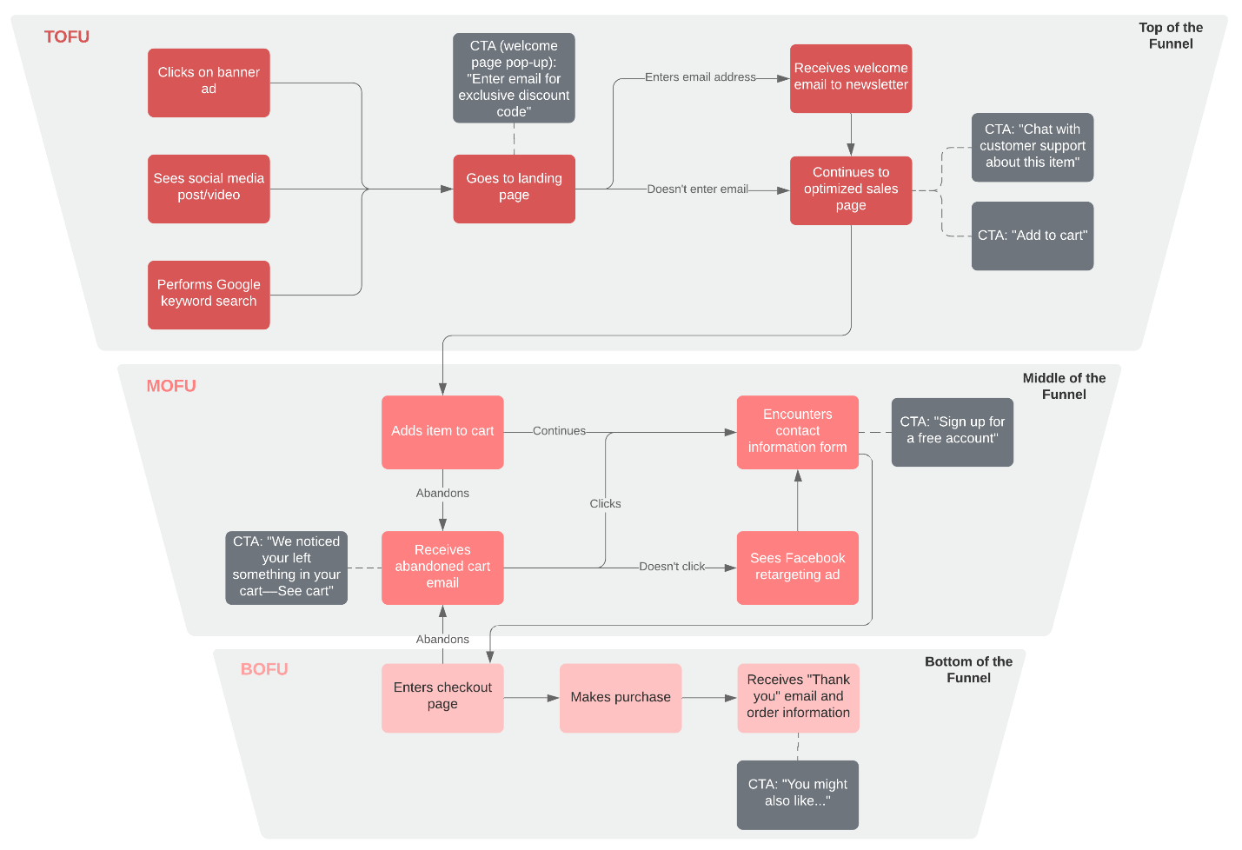](https://www.lucidchart.com/documents/editNewOrRegister/4365363e-ef85-4112-b639-0dd5efe2b9c9?anonId=0.4bbc082618c7d97a17f&sessionDate=2023-12-18T15%3A46%3A04.514Z&sessionId=0.a3e6a45f18c7d97a180)Content Map With Funnel (B2C) Example

When researching their options, consumers again rely on internal and external factors, as well as past interactions with a product or brand, both positive and negative. In the information stage, they may browse through options at a physical location or consult online resources, such as Google or customer reviews.

Your job as a brand is to give the potential customer access to the information they want, with the hopes that they decide to purchase your product or service. Create a funnel and plan out the types of content that people will need. Present yourself as a trustworthy source of knowledge and information.

Another important strategy is word of mouth—since consumers trust each other more than they do businesses, make sure to include consumer-generated content, like customer reviews or video testimonials, on your website.

Example: The customer searches “women’s winter coats” on Google to see what options are out there. When she sees someone with a cute coat, she asks them where they bought it and what they think of that brand.

### **3**. **Alternatives evaluation**

At this point in the consumer decision-making process, prospective buyers have developed criteria for what they want in a product. Now they weigh their prospective choices against comparable alternatives.

Alternatives may present themselves in the form of lower prices, additional product benefits, product availability, or something as personal as color or style options. Your marketing material should be geared towards convincing consumers that your product is superior to other alternatives. Be ready to overcome objections—e.g., in sales calls, know your competitors so you can answer questions and compare benefits.

Example: The customer compares a few brands that she likes. She knows that she wants a brightly colored coat that will complement the rest of her wardrobe, and though she would rather spend less money, she also wants to find a coat made from sustainable materials.

### **4. Purchase decision**

This is the moment the consumer has been waiting for: the purchase. Once they have gathered all the facts, including feedback from previous customers, consumers should arrive at a logical conclusion on the product or service to purchase.

If you’ve done your job correctly, the consumer will recognize that your product is the best option and decide to purchase it.

Example: The customer finds a pink winter coat that’s on sale for 20% off. After confirming that the brand uses sustainable materials and asking friends for their feedback, she orders the coat online.

### **5. Post-purchase evaluation**

This part of the consumer decision-making process involves reflection from both the consumer and the seller. As a seller, you should try to gauge the following:

* Did the purchase meet the need the consumer identified?
* Is the customer happy with the purchase?
* How can you continue to engage with this customer?

Remember, it’s your job to ensure your customer continues to have a positive experience with your product. Post-purchase engagement could include follow-up emails, discount coupons, and newsletters to entice the customer to make an additional purchase. You want to gain life-long customers, and in an age where anyone can leave an online review, it’s more important than ever to keep customers happy.

**Ans to the question no. 3:**

Consumer buying behavior is influenced by a variety of factors, and businesses often employ strategies to shape these influences. Here are some key factors that can influence consumer buying behavior:

1. **Advertising and Marketing:**

* **Traditional Media:** Television, radio, print, and online advertising play a significant role in shaping consumer perceptions. Well-crafted and memorable ads can create brand awareness and influence preferences.
* **Digital Marketing:** With the rise of online platforms, digital marketing, including social media advertising, influencer marketing, and content marketing, can reach specific target audiences and engage with consumers on a more personal level.

1. **Social Influence:**

* **Word of Mouth:** Personal recommendations from friends, family, or colleagues can heavily impact consumer decisions. Social proof and testimonials contribute to building trust in a product or brand.
* **Influencer Marketing:** Collaborating with influencers who have a substantial following in a particular niche allows brands to reach a broader audience and leverage the influencer's credibility.

1. **Cultural Factors:**

* **Cultural Appeal:** Understanding cultural nuances and adapting marketing strategies to align with cultural values and preferences can make a product more appealing to specific consumer groups.
* **Localization:** Adapting products or marketing campaigns to suit local cultures and traditions enhances relevance and acceptance.

1. **Psychological Factors:**

* **Consumer Motivation:** Identifying and appealing to consumers' motivations, whether it's the desire for status, achievement, or convenience, can influence purchasing decisions.
* **Perception and Attitudes:** Marketing messages can shape how consumers perceive a product or brand. Positive associations and attitudes contribute to a favorable buying decision.

1. **Personalization:**

* **Data-Driven Personalization:** Analyzing consumer data allows businesses to personalize marketing messages and offers based on individual preferences, browsing history, and past purchases.
* **Targeted Advertising:** Targeting specific demographics or segments with tailored advertising increases the likelihood of resonating with the intended audience.

1. **Brand Image and Reputation:**

* **Brand Trust:** Establishing and maintaining a positive brand image and reputation is crucial. Brands with a history of quality, reliability, and ethical practices are more likely to influence consumer choices.

1. **Price and Discounts:**

* **Pricing Strategies:** Setting competitive prices and offering discounts, promotions, or loyalty programs can influence consumer perceptions of value for money.
* **Psychological Pricing:** Strategies like pricing just below a round number or emphasizing discounts create a psychological impact on consumers.

1. **Online Presence:**

* **User Experience:** A user-friendly website, easy navigation, and a seamless online purchasing process contribute to a positive consumer experience.
* **Online Reviews and Ratings:** Positive reviews and high ratings build credibility and trust. Negative reviews can have the opposite effect, highlighting the importance of managing online reputation.

1. **Consumer Experience:**

* **Customer Service:** Excellent customer service before, during, and after a purchase enhances the overall consumer experience. Positive interactions contribute to brand loyalty and positive word of mouth.

1. **Emotional Appeal:**

* **Emotional Marketing:** Creating emotional connections through storytelling, relatable narratives, or campaigns that tap into consumers' emotions can leave a lasting impression and influence purchasing decisions.

In summary, businesses employ a combination of these strategies, often tailored to their specific industry and target audience, to effectively influence consumer buying behavior. The goal is to create a positive and compelling brand experience that resonates with consumers and encourages them to choose a particular product or service.

**Ans to the question no. 4:**

**a. Holistic marketing philosophy:**  
Holistic marketing is a comprehensive approach that views marketing as an interconnected and integral part of the entire business ecosystem. It goes beyond traditional marketing strategies, incorporating internal marketing, relationship marketing, socially responsible practices, and a customer-centric approach. This philosophy emphasizes the seamless integration of all marketing efforts, both internal and external, to create a consistent and unified brand experience. It recognizes the significance of ethical marketing practices, market responsiveness, and the measurement of performance metrics to ensure a long-term, sustainable impact on customer satisfaction and loyalty. Holistic marketing aligns marketing strategies with the broader organizational goals, considering the interconnectedness of all elements within the business for a more comprehensive and effective approach.

**b. Customer-Perceived value:**

Customer-perceived value is the subjective assessment that customers make about the overall worth of a product or service based on their individual needs, preferences, and experiences. It goes beyond the tangible attributes and price, encompassing factors such as quality, convenience, brand reputation, and the emotional connection a customer feels with a brand. Essentially, it's the customer's judgment of what they receive relative to what they give in a transaction. High customer-perceived value occurs when the benefits and satisfaction derived from a product or service outweigh the perceived costs, leading to customer loyalty and positive word-of-mouth. Businesses strive to enhance customer-perceived value by understanding and addressing customer needs, delivering consistent quality, and creating positive experiences throughout the customer journey.