Name: Nur Ahammad

ID: 1121520011

BBA Program

Batch: 52

Semester: Summer 2023

Course Code: POM-325

Course Title: Production and Operations Management

**Answer All Questions**

**1. Who is qualified worker? Discuss about Work Measurement Techniques.**

**2. Define Fixed Product Layout. Write down advantages and limitations of fixed product layout.**

**3. Illustrate & discuss learning curve with a proper diagram.**

**4. What to expect from CADD?**

**Answer to the question no. 1**

A qualified worker typically refers to an individual who possesses the necessary skills, education, training, and experience to perform a specific job or task competently. The qualifications of a worker can vary depending on the nature of the job and the industry. Here are some common factors that contribute to a worker being considered qualified:

1. **Education and Training:**
   * A qualified worker often has the required educational background and has undergone relevant training related to the job. This could include academic degrees, vocational training, or certifications.
2. **Skills and Competencies:**
   * Possession of the specific skills and competencies needed for the job is a key qualification. These skills may be technical, interpersonal, analytical, or a combination, depending on the job requirements.
3. **Experience:**
   * Work experience in a related field is often a qualification criterion. Previous on-the-job experience provides practical knowledge and an understanding of industry practices.
4. **Certifications and Licenses:**
   * Some jobs require specific certifications or licenses. A qualified worker in such cases would have obtained the necessary credentials to legally and competently perform the tasks associated with the job.
5. **Knowledge of Industry Standards:**
   * Being familiar with industry standards, regulations, and best practices is important. This knowledge ensures that the worker can perform the job in compliance with relevant guidelines and standards.
6. **Adaptability and Learning Agility:**
   * In dynamic work environments, the ability to adapt to changes and learn new skills quickly is highly valuable. A qualified worker is often someone who can continuously update their knowledge and skills to stay relevant in their field.
7. **Communication and Teamwork:**
   * Effective communication and the ability to work well with others are often considered qualifications. Many jobs require collaboration and the ability to communicate ideas, information, and instructions clearly.
8. **Problem-Solving Abilities:**
   * A qualified worker should be capable of analyzing situations, identifying problems, and implementing effective solutions. Problem-solving skills contribute to efficiency and productivity.
9. **Ethical and Professional Behavior:**
   * Ethical conduct and professional behavior are essential qualifications. Workers are expected to adhere to ethical standards and behave professionally in the workplace.
10. **Physical Fitness (if applicable):**
    * In certain industries, physical fitness may be a qualification criterion. Jobs that involve manual labor or specific physical demands may require workers to meet certain fitness standards.

**Work measurement techniques:** These methods used to assess and quantify the amount of time required to perform a specific task or job. These techniques are essential in various industries for optimizing efficiency, setting standards, and improving productivity. Here are some commonly used works measurement techniques:

1. **Time and Motion Study:**
   * Time and motion study, pioneered by Frederick Taylor, involves breaking down a task into its basic motions and analyzing the time required for each motion. This technique aims to identify the most efficient way to perform a task by eliminating unnecessary movements and streamlining processes.
2. **Predetermined Motion Time System (PMTS):**
   * PMTS is a predetermined time standard system that assigns a time value to basic human motions involved in performing a task. It uses pre-established time values for specific movements, allowing for quick and standardized assessments of task times.
3. **Work Sampling:**
   * Work sampling, also known as activity sampling, involves taking random observations of a worker's activities over a period. It provides a statistical estimate of the proportion of time spent on different tasks, offering insights into the overall work pattern.
4. **Standard Data:**
   * Standard data systems use pre-determined standard times for various work elements. These standard times are often compiled in databases, and analysts can use them to estimate the time required for specific tasks based on historical data.
5. **MOST (Maynard Operation Sequence Technique):**
   * MOST is a systematic and comprehensive work measurement system that breaks down a job into basic motions, assigns times to each motion, and accounts for various factors such as fatigue and delays. It is widely used in manufacturing and assembly line settings.
6. **MTM (Methods-Time Measurement):**
   * MTM is a predetermined motion time system that categorizes basic motions into predetermined time values. It is widely used for setting time standards in manufacturing processes and is known for its focus on standardizing methods.
7. **Time Study:**
   * Time study involves the direct observation of a worker performing a task to assess the time required for each element of the job. This data is then used to establish time standards for the task.
8. **Video Analysis:**
   * With advancements in technology, video analysis is becoming more common. High-speed cameras and video recording allow analysts to review and analyze work processes in detail, identifying areas for improvement.
9. **GSD (General Sewing Data):**
   * GSD is a work measurement system specifically designed for the apparel industry. It provides standardized times for various sewing operations, helping in the optimization of garment manufacturing processes.
10. **Computer-Aided Work Measurement:**
    * Modern technologies and software applications are increasingly used for work measurement. Computer-aided techniques help in data collection, analysis, and the generation of time standards, enhancing efficiency and accuracy.

These work measurement techniques are employed based on the nature of the task, industry requirements, and the level of precision needed in the assessment of work processes. The goal is to establish accurate time standards, improve productivity, and create efficient workflows in various organizational settings.

**Answer to the question no. 2**

A Fixed Product Layout, also known as a product-oriented layout or a static layout, is a manufacturing layout design in which the arrangement of production facilities and equipment is set up to produce a specific product efficiently. In this layout, the physical configuration of machinery, workstations, and resources remains fixed or unchanged, and the production process is designed to accommodate the specific requirements of a particular product.

Examples of industries that commonly use Fixed Product Layouts include automobile manufacturing, electronics assembly, and certain types of food production. While these layouts offer high efficiency for specific products, they may face challenges in adapting to changes in product design or accommodating a diverse range of products. As a result, businesses need to carefully consider the trade-offs between efficiency and flexibility when choosing a layout strategy.

**Advantages of Fixed Product Layout:**

1. **High Efficiency:**
   * Fixed product layouts are designed for efficiency in producing a specific product or a range of similar products. The sequential arrangement of workstations minimizes material handling and reduces production time.
2. **Low Unit Cost:**
   * The specialization and standardization inherent in fixed product layouts often lead to lower unit costs for the targeted product. High volumes and repetitive processes contribute to economies of scale.
3. **Reduced Material Handling:**
   * With a predetermined and fixed flow of the product through the production process, there is minimal need for material handling between workstations. This reduces the risk of errors and delays.
4. **Optimized Equipment Use:**
   * Equipment is specifically arranged to suit the production requirements of the designated product. This optimization results in efficient use of machinery and resources.
5. **Streamlined Production Planning:**
   * Production planning is simplified in fixed product layouts as the process is standardized. This allows for better forecasting, scheduling, and overall coordination of production activities.
6. **Lower Training Costs:**
   * Because the layout is fixed and the processes are standardized, training costs for workers are often lower. Employees become specialized in their tasks, leading to increased skill proficiency.
7. **Automation Integration:**
   * Fixed product layouts are well-suited for the integration of automation and robotics. Automated systems can enhance precision, consistency, and overall production efficiency.

**Limitations of Fixed Product Layout:**

1. **Lack of Flexibility:**
   * One of the primary drawbacks is the lack of flexibility. Changing the product design or introducing a new product may require significant reconfiguration of the layout, leading to downtime and additional costs.
2. **High Initial Investment:**
   * The initial investment in setting up a fixed product layout can be high. Specialized equipment and infrastructure are needed, and the costs may not be easily recouped if there are changes in product demand or design.
3. **Limited Variety:**
   * Fixed product layouts are suitable for a specific product or a narrow range of similar products. They are not well-suited for environments where there is a need for a high variety of products.
4. **Dependency on Production Volume:**
   * The efficiency of fixed product layouts is highly dependent on high production volumes. If production volumes decrease, the fixed costs associated with the layout may lead to higher unit costs.
5. **Difficulty in Handling Custom Orders:**
   * Customization or handling custom orders can be challenging in fixed product layouts. The standardized processes may not easily accommodate variations in product specifications.
6. **Maintenance Challenges:**
   * Maintenance and repairs may be more challenging in fixed layouts. Downtime for maintenance can disrupt the entire production process, impacting efficiency.
7. **Resistance to Change:**
   * Employees may become resistant to change in fixed product layouts. Any modifications or adjustments to the layout may face resistance, affecting workforce morale and productivity.

In conclusion, while fixed product layouts offer high efficiency and cost advantages for specific product lines, they come with limitations related to flexibility, adaptability, and initial investment. The decision to adopt a fixed product layout should be based on careful consideration of the production requirements, market dynamics, and the potential for changes in product demand.

**Answer to the question no. 3**

A learning curve gives a graphical depiction of learning a particular task over time. In a typical instructional curve graph, the horizontal x-axis represents the time or number of attempts, while the vertical y-axis represents performance at the task.

There are a few recognizable shapes that the learning curve theory follows. The first is a diminishing-returns curve, which has a line that rapidly increases at the beginning but flattens out at the top. Another is the increasing-returns learning curve, which starts off slowly rising at the beginning but ends in a rapid increase. The third type of learning curve is the S-curve, which starts slowly increasing before rising rapidly, only to level off at the end. One more type of curve is a complex curve, which shows a more realistic pattern of development that can be slow or fast at different times.

**Diminishing-returns Learning Curve**

In this type of curve, we can see that a task is easy to learn at the beginning but eventually plateaus. This can mean that a learner has either reached the limit of learning at this task or that they have become disinterested in doing better. At this point, they need some new active or experiential learning stimulus to reach the next level.

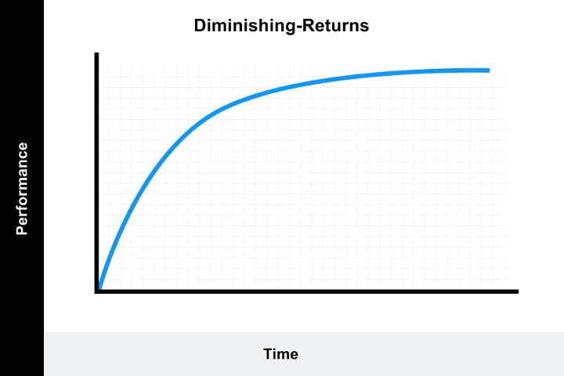

**Increasing-returns curve**

This curve that starts slowly before taking off can occur for a few different reasons. It can be that a task is very complicated to understand at first, but once a few difficult concepts are understood, then things become easy. There also could have been some additional pedagogical intervention, such as gamification, that caused the learner to suddenly become interested, resulting in a learning curve steep and tall.

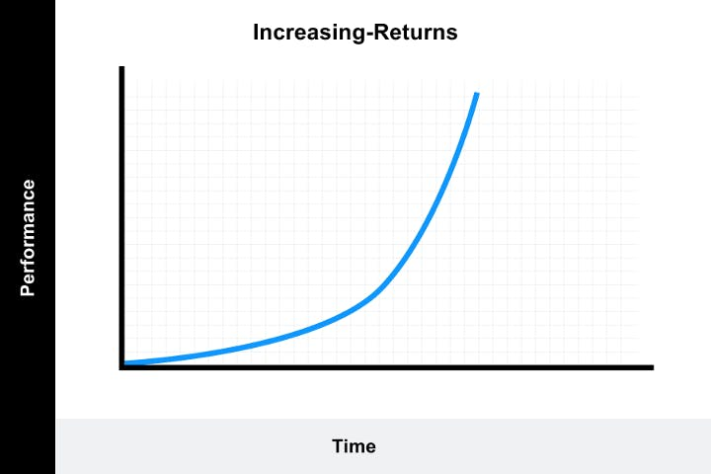

**S-curve**

This curve combines elements of the other two. It can represent a task that takes time to learn but accelerates quickly after that until another difficulty is faced. This type of curve should be made steeper by addressing the lulls when the learner is either not engaged or can’t understand topics that are too difficult.

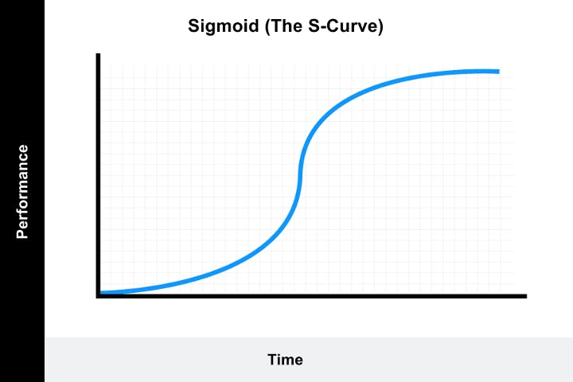

**Complex curve**

A complex curve can show different speeds of student pedagogy until a skill is mastered. Once a skill is mastered, it can still keep moving. This type of curve is more realistic, especially for corporate training environments where learners have to negotiate various priorities in addition to their learning requirements.

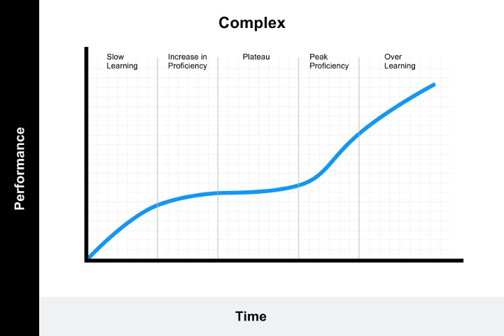

Now that we’ve defined what a learning curve is and seen some different shapes for learning curves, you may be wondering what the point of having them is. Let’s take a minute and see why it matters to use learning curves.

**Answer to the question no. 4**

**Computer-Aided Design and Drafting (CADD)** is a technology that has transformed the fields of design, engineering, and architecture. Here's what you can generally expect from CADD:

1. **Precision and Accuracy:**
   * CADD allows for highly precise and accurate design and drafting. It eliminates manual errors and enables designers to create detailed and complex drawings with a high degree of accuracy.
2. **Efficiency in Design:**
   * CADD tools streamline the design process, making it more efficient. Designers can easily modify and edit drawings, test different design iterations, and make quick adjustments without starting from scratch.
3. **Visualization and 3D Modeling:**
   * CADD provides powerful 3D modeling capabilities, allowing designers to create realistic and detailed representations of objects, buildings, or systems. This aids in visualization and enhances the understanding of the design.
4. **Collaboration and Sharing:**
   * CADD facilitates collaboration among team members, even if they are geographically dispersed. Design files can be easily shared, reviewed, and edited by multiple contributors in real-time.
5. **Design Automation:**
   * Automation features in CADD tools enable the creation of parametric designs. Changes to one part of the design automatically update related elements, reducing manual effort and ensuring consistency.
6. **Simulations and Analysis:**
   * Many CADD tools come with simulation and analysis capabilities. Engineers can simulate how designs will behave under various conditions, perform stress analysis, or simulate fluid flow, enhancing the understanding of design performance.
7. **Documentation and Standards Compliance:**
   * CADD tools assist in the creation of comprehensive documentation. Designs can be annotated, and drawings can include dimensions, specifications, and other details required for manufacturing or construction. Compliance with industry standards is also facilitated.
8. **Integration with Other Tools:**
   * CADD tools often integrate with other software applications, such as project management tools, analysis software, and data management systems, creating a seamless workflow and improving overall project efficiency.
9. **Cost and Time Savings:**
   * CADD significantly reduces the time required for design and drafting tasks. The efficiency gains translate into cost savings as projects can be completed more quickly and with fewer resources.
10. **Adaptability and Customization:**
    * CADD tools are highly adaptable and customizable. Users can configure the tools to match specific project requirements, and plugins or add-ons can be integrated to extend functionality.
11. **Training and Skill Development:**
    * Proficiency in CADD tools is a valuable skill in various industries. Training in CADD enhances the skill set of designers, engineers, and architects, making them more competitive in the job market.
12. **Environmental Impact Assessment:**
    * CADD tools are often used for environmental impact assessments, allowing designers to evaluate the environmental consequences of a design and make adjustments to minimize negative effects.

In conclusion, CADD revolutionizes the design and drafting process by providing powerful tools for precision, efficiency, collaboration, and analysis. Its impact is felt across industries, from architecture and engineering to manufacturing and construction, contributing to improved productivity and the realization of innovative and complex designs.