Name: Nur Ahammad

ID: 1121520011

BBA Program

Batch: 52

Semester: Spring 2023

Course Code: MGT 440

Course Title: Strategic Management

**Answer All Questions**

**1. Define Strategic Management.**

**2. Discuss About Strategies to Manage Rivals.**

**3. Illustrate Different Groups of Customers With a Proper Diagram.   
4. What are the Main Ways to turn a Fragmented Industry into a Consolidated One?**

**5. Briefly Distinctive Competencies.**

**Answer to the question no. 1**

Strategic management refers to the process of defining an organization's overall goals and objectives, and formulating and implementing strategies to achieve them. This process involves assessing the organization's internal and external environment, identifying strengths, weaknesses, opportunities, and threats (SWOT analysis), and then developing plans and tactics to achieve the desired outcomes.

The strategic management process typically involves several steps, including:

* Goal setting: This involves identifying and defining the organization's long-term goals and objectives.
* Environmental analysis: This involves assessing the organization's internal and external environment to identify factors that may affect its ability to achieve its goals.
* SWOT analysis: This involves identifying the organization's strengths, weaknesses, opportunities, and threats.
* Strategy formulation: This involves developing strategies to achieve the organization's goals and objectives based on the SWOT analysis.
* Strategy implementation: This involves putting the strategies into action through allocation of resources, implementation of plans and tactics, and monitoring progress towards achieving the desired outcomes.
* Strategy evaluation and control: This involves monitoring and evaluating the effectiveness of the strategies and making necessary adjustments to ensure they are aligned with the organization's goals and objectives.

Effective strategic management helps organizations to adapt to changes in their environment, seize opportunities, and overcome challenges. It provides a framework for making decisions that are aligned with the organization's goals and helps to ensure that all activities are coordinated towards achieving the desired outcomes.

**Answer to the question no. 2**

In any competitive market, rivalry is inevitable. Competitors may offer similar products or services, compete for the same customers, or aim to dominate the same market segments. While competition can be healthy, it can also be challenging for businesses. To manage rivals effectively, organizations need to develop strategies that enable them to compete effectively while protecting their market share and profitability. Here are some strategies to manage rivals:

1. Differentiation Strategy: This involves creating unique products or services that are difficult for rivals to replicate. Organizations can differentiate their products or services by improving quality, offering better customer service, or leveraging innovation and technology.
2. Cost Leadership Strategy: This involves reducing the cost of production to offer products or services at lower prices than rivals. Organizations can achieve cost leadership by improving efficiency, investing in automation and technology, and optimizing their supply chain.
3. Focus Strategy: This involves targeting a specific niche or segment of the market to offer products or services that meet their unique needs. Organizations can focus on a particular market segment by customizing their products or services, developing specialized expertise, or building relationships with key customers.
4. Collaboration Strategy: This involves partnering with rivals to achieve common goals. Organizations can collaborate with rivals to reduce costs, share resources, or develop new products or services.
5. Competitive Intelligence Strategy: This involves gathering and analyzing information about rivals to understand their strengths, weaknesses, strategies, and market position. Organizations can use competitive intelligence to anticipate rivals' moves, develop counter-strategies, and identify opportunities for growth.
6. Legal Action Strategy: This involves taking legal action against rivals who engage in unethical or illegal practices, such as patent infringement, price fixing, or anti-competitive behavior.

Overall, managing rivals requires a strategic approach that balances the need to compete with the need to maintain profitability and market share. Organizations that can effectively manage rivals are better positioned to succeed in competitive markets.

**Answer to the question no. 3**

Customers can be classified into different groups based on their common characteristics, needs, behaviors, and preferences. Understanding the different groups of customers is essential for businesses to develop effective marketing strategies, deliver personalized customer experiences, and meet customer needs better.

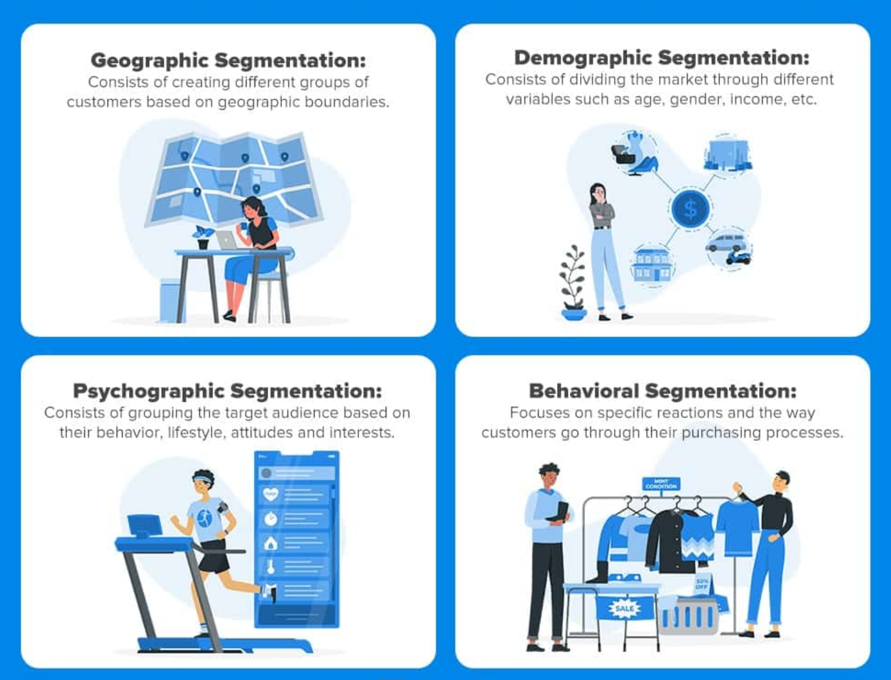

**Figure**: Four Main Groups

Here are some of the main groups of customers:

1. Demographic Groups: This includes customers who share common demographic characteristics, such as age, gender, income, education, and occupation. Demographic groups can help businesses to target specific customer segments based on their needs, behaviors, and preferences.
2. Geographic Groups: This includes customers who share common geographic characteristics, such as location, climate, and cultural norms. Geographic groups can help businesses to tailor their products, services, and marketing messages to local or regional needs.
3. Psychographic Groups: This includes customers who share common personality traits, values, attitudes, and lifestyles. Psychographic groups can help businesses to understand customers' motivations, preferences, and behaviors, and deliver personalized experiences.
4. Behavioral Groups: This includes customers who share common buying behaviors, such as loyalty, frequency of purchase, and purchasing habits. Behavioral groups can help businesses to identify customer segments that are most profitable and develop targeted marketing and loyalty programs.
5. Technographic Groups: This includes customers who share common technology usage patterns, such as social media, mobile devices, and internet usage. Technographic groups can help businesses to target customers based on their preferred channels of communication and engagement.
6. Firmographic Groups: This includes customers who share common organizational characteristics, such as industry, company size, and organizational structure. Firmographic groups can help businesses to identify customer segments that have similar needs and develop targeted B2B marketing and sales strategies.

Understanding the different groups of customers can help businesses to develop targeted marketing strategies, optimize their customer experiences, and build long-term customer relationships. By catering to the unique needs and preferences of different customer groups, businesses can improve customer satisfaction, increase loyalty, and drive revenue growth.

**Answer to the question no. 4**

A fragmented industry is one in which there are numerous small players competing for a small share of the market. In such industries, consolidation can be achieved by bringing together small players to create larger, more dominant companies. Here are some of the main ways to turn a fragmented industry into a consolidated one:

* Mergers and Acquisitions: This involves merging two or more companies or acquiring smaller companies to create a larger, more dominant player in the market. This strategy can result in cost savings, economies of scale, and increased market share.
* Strategic Alliances: This involves forming partnerships or alliances with other companies to share resources, knowledge, and expertise. Strategic alliances can help to increase market share, reduce costs, and leverage the strengths of each partner.
* Franchising: This involves offering licenses to other companies or individuals to use a company's brand name, products, and services in exchange for a fee. Franchising can help to expand a company's reach and increase market share, while also reducing costs and risk.
* Joint Ventures: This involves forming a new company with other companies to pursue a specific project or goal. Joint ventures can help to leverage the strengths of each partner, while also sharing the risks and costs associated with the project.
* Consolidation through Market Forces: This occurs naturally as smaller players are acquired by larger players or go out of business due to increased competition and lower margins. This can result in a few dominant players in the market.

Consolidation can be a challenging and complex process, and it requires careful planning, execution, and management. However, it can result in significant benefits for the industry, including increased efficiency, competitiveness, and profitability.

**Answer to the question no. 5**

Distinctive competencies are the unique capabilities and resources that give an organization a competitive advantage over its rivals in the marketplace. These competencies are the skills, knowledge, processes, or assets that allow an organization to differentiate itself from competitors, meet customer needs better, and achieve superior performance.

Distinctive competencies can be categorized into two types: core competencies and unique competencies. Core competencies are the capabilities and resources that are fundamental to an organization's operations and strategy. These competencies are typically shared across the organization and are used in multiple products, services, or markets. Core competencies are difficult for competitors to replicate and can provide the basis for developing new products, expanding into new markets, or achieving cost efficiencies.

Examples of core competencies include supply chain management, customer service, and research and development. Unique competencies are the capabilities and resources that are specific to an organization's products, services, or markets. These competencies are often the result of unique knowledge, technology, or expertise that sets an organization apart from its rivals.

Examples of unique competencies include a proprietary technology, a patent, or a specific type of distribution network.

However distinctive competencies can be developed through various means, including investing in research and development, acquiring new technologies or companies, and developing talent and skills within the organization. Organizations that can leverage their distinctive competencies are better positioned to compete in the marketplace, achieve superior performance, and create value for customers and stakeholders.