Name: Nur Ahammad

ID: 1121520011

BBA Program

Batch: 52

Semester: Spring 2023

Course Code: ECO 219

Course Title: Macro Economics

**Answer All Questions**

**1. Define Macro Economics 1**

**2. Illustrate demand and supply equilibrium point with a proper diagram. 6**

**3. Illustrate with Productive and Allocative Efficiency a proper diagram. 6**

**4. What are the factors that can shift demand? 6**

**5. Why we Study Economics? 6**

**Answer to the question no. 1**

**Macro Economics:** Macroeconomics is the branch of economics that deals with the overall performance, structure, and behavior of the economy as a whole, rather than individual markets or firms. It focuses on issues such as economic growth, inflation, unemployment, and government policies that affect the economy at the national or global level. Macroeconomic analysis uses a range of indicators and models to understand and predict economic trends, such as gross domestic product (GDP), consumer price index (CPI), and unemployment rate. The goal of macroeconomics is to promote sustainable economic growth, stability, and welfare for society as a whole.

**Answer to the question no. 2**

The demand and supply equilibrium point is a crucial concept in economics that describes the price and quantity of a good or service that will prevail in a market where demand and supply intersect. At this point, the quantity demanded by consumers equals the quantity supplied by producers, resulting in no excess supply or demand.

To understand the concept of the equilibrium point, it is important to first understand the law of demand and the law of supply. The law of demand states that the quantity of a good or service demanded by consumers will decrease as the price of that good or service increases. Conversely, the quantity demanded will increase as the price decreases. This relationship between price and quantity demanded is shown graphically as a downward sloping demand curve.

The law of supply, on the other hand, states that the quantity of a good or service supplied by producers will increase as the price of that good or service increases. Conversely, the quantity supplied will decrease as the price decreases. This relationship between price and quantity supplied is shown graphically as an upward sloping supply curve.

The equilibrium point is the point at which the quantity demanded by consumers and the quantity supplied by producers are equal. Graphically, this point is represented by the intersection of the demand and supply curves. At this point, the market is said to be in a state of equilibrium, with no excess demand or supply.

We can locate the equilibrium point on a demand and supply graph, where both the demand curve and supply curve intersect each other at a certain point.

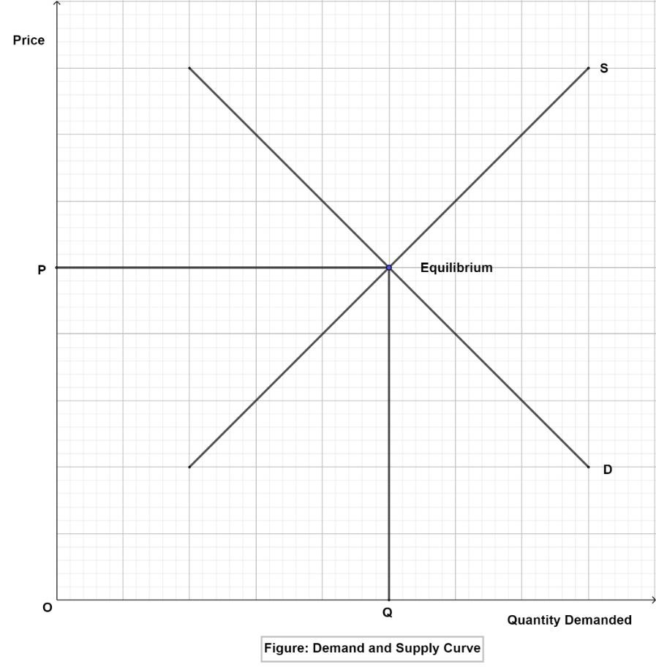

**Explanation-**

The demand curve has a downward sloping that shows the inverse relationship between price & quantity.

The supply curve has an upward sloping that reflects a positive relationship between price and quantity.

A certain point where both curves intersect refers to as Equilibrium.

When the market is in equilibrium, the price and quantity of the good or service will be determined by the intersection of the demand and supply curves. If the price is above the equilibrium price, there will be excess supply, meaning that producers will be supplying more of the good or service than consumers are willing to buy. This will put downward pressure on the price, causing it to fall towards the equilibrium price. If the price is below the equilibrium price, there will be excess demand, meaning that consumers will be demanding more of the good or service than producers are willing to supply. This will put upward pressure on the price, causing it to rise towards the equilibrium price.

In summary, the demand and supply equilibrium point is the point at which the quantity demanded by consumers and the quantity supplied by producers are equal, resulting in a market where there is no excess demand or supply. The equilibrium point is determined by the intersection of the demand and supply curves, and it represents the price and quantity that will prevail in a competitive market.

**Answer to the question no. 3**

Productive efficiency is concerned with the optimal method of producing goods, producing goods at the lowest cost.

On the other hand allocative efficiency is concerned with the optimal distribution of goods and services.

**Example**: An economy could be productively efficient in producing large numbers of boots – but if they were all for the left foot, it would be allocatively inefficient as no one would benefit from these low production costs.

**Definition of productive efficiency**

This is defined as producing goods and services for the lowest cost. Productive efficiency is said to occur on the production possibility frontier. On the PPF curve, it is impossible to produce more of one good without producing less of another.

In the diagram below, if you are at point A, you can’t produce more services without foregoing goods.

[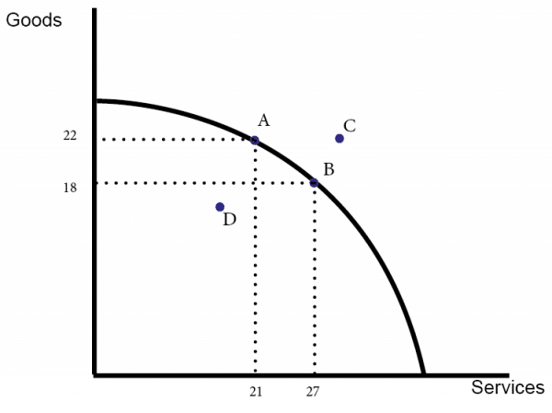](https://www.economicshelp.org/wp-content/uploads/2012/11/ppf-opp-cost-id.png)

Point D in the graph is productively inefficient because you can produce more goods or services without an opportunity cost.

**Lowest point on SRAC Curve**

Productive efficiency also involves producing at the lowest point of the short run average cost curve (where MC cuts the bottom of the SRAC curve.)

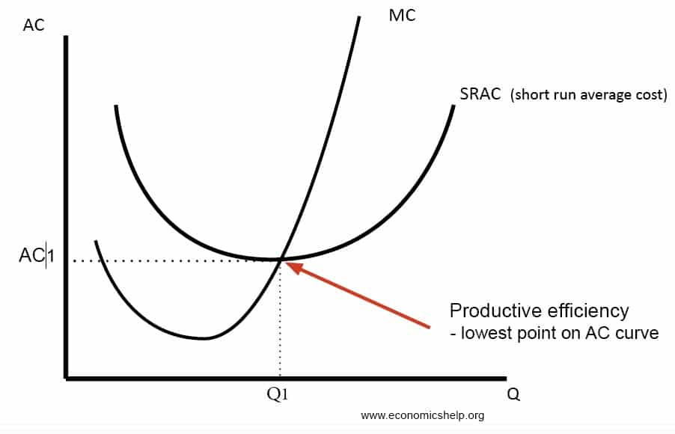

Usually, productive efficiency refers to the short run (i.e. producing at the lowest point of SRAC curve) But if can also refer to producing at the lowest point on the Long Run Average Cost curve LRAC i.e. benefiting from [economies of scale.](https://www.economicshelp.org/microessays/costs/economies-scale.html)

Related to productive efficiency is the concept of [technical efficiency](https://www.economicshelp.org/blog/glossary/technical-efficiency/). Technical efficiency specifically refers to the optimal combination of inputs, i.e. using the minimum combination of labour and capital to produce a certain quantity of goods.

**Allocative Efficiency definition**

Allocative efficiency is quite different and is more concerned with the distribution and allocation of resources in society.

[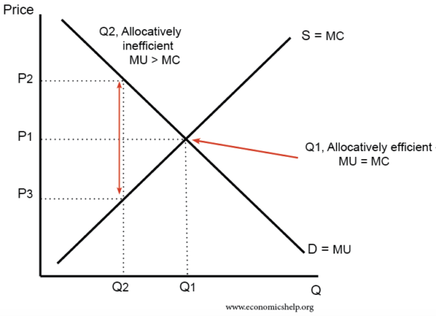](https://www.economicshelp.org/wp-content/uploads/2017/06/allocative-efficiency.png)

Allocative efficiency looks at the marginal benefit of consumption compared to the marginal cost. Allocative efficiency will occur at an output when marginal benefit (price) = marginal cost.

We can say:

* Allocative efficiency occurs where price = marginal cost (MC)
* Monopolies are often said to be allocatively inefficient because they are able to set the price higher than marginal cost.

Related to allocative efficiency is the concept of social efficiency. Social efficiency makes a point of taking into account all externalities so we can try and equate social marginal benefit and social marginal cost.

**Which is most important productive or allocative efficiency?**

There would be no point in being productively efficient if all resources are diverted to making guns. We could be producing on a production possibility frontier but, if it is all guns, society would not have enough food or health care.

An anecdote from the Soviet Union under Communist days tells how factories were given targets to produce certain quantities of goods. They often did this with great vigour and were productively efficient, but, often they were producing goods which weren’t needed by society. There is a story that one factory made left-hand boots that nobody wanted, so at the end of the day they would efficiently burn them and the next day start again! They were productively efficient but not allocatively efficient.

However, productive efficiency is still important. If goods are produced at a lower cost it enables society to have a better trade-off and enable the scope for people to consume more goods and services.

**Answer to the question no. 4**

Several factors can shift the demand curve, causing a change in the quantity demanded at each price level. Here are some of the most important factors that can shift the demand curve:

1. Consumer income: When consumers' income increases, they may be willing to buy more goods and services, resulting in an increase in demand. Conversely, a decrease in income may lead to a decrease in demand.
2. Prices of related goods: The prices of related goods, such as substitutes and complements, can affect the demand for a particular good. If the price of a substitute good increases, the demand for the original good may increase. If the price of a complementary good decreases, the demand for the original good may increase.
3. Consumer preferences and tastes: Changes in consumer preferences and tastes can lead to shifts in demand for goods and services. For example, if a particular food becomes more popular, the demand for that food may increase.
4. Population changes: Changes in the size and composition of the population can affect demand for goods and services. An increase in the population or a change in the age distribution may increase demand for certain goods.
5. Advertising and promotion: Effective advertising and promotion campaigns can increase consumer awareness and demand for a particular good or service.
6. Changes in consumer expectations: Changes in consumer expectations about future prices or income can affect demand. If consumers expect prices to increase in the future, they may demand more of a good or service now.

These are just some of the factors that can shift the demand curve. It's important to note that each of these factors can affect demand differently, depending on the type of good or service and other market conditions.

**Answer to the question no. 5**

There are several reasons why we study economics. Here are some of the main ones:

1. **Understanding how the economy works**: Economics is a social science that studies the production, consumption, and distribution of goods and services. It provides us with a framework for understanding how markets work and how the economy as a whole operates. By studying economics, we can gain insights into why prices and quantities of goods and services change, how businesses make decisions, and how government policies can affect the economy.

For example, microeconomics helps us understand how individuals and firms make decisions about what to produce, how much to produce, and at what price. Macroeconomics helps us understand the broader trends and fluctuations in the economy, such as economic growth, inflation, and unemployment.

1. **Making informed decisions:** Economics helps us make better decisions in our personal and professional lives. By understanding economic concepts such as opportunity cost and trade-offs, we can make informed decisions about how to allocate our time, money, and resources.

For example, economics can help us make decisions about which career to pursue, how much to save for retirement, or whether to buy or rent a home. It can also help businesses make decisions about pricing strategies, production levels, and investments.

1. **Policy-making:** Economics provides the basis for government policy-making, such as taxation, public spending, and regulation. By understanding the economic impacts of different policies, policymakers can make informed decisions that benefit society as a whole.

For example, economists can analyze the effects of tax policies on incentives to work and save, the impacts of public spending on economic growth, and the costs and benefits of environmental regulation.

1. **Career opportunities:** Economics is a versatile field that provides career opportunities in a variety of industries, including finance, consulting, public policy, and academia. By studying economics, students develop analytical and critical thinking skills that are valued by employers in many industries.

For example, economists can work in investment banks, consulting firms, government agencies, and non-profit organizations. They can also pursue careers in academia, conducting research and teaching economics to future generations.

1. **Global perspective**: Economics provides us with a global perspective on economic issues and challenges. It helps us understand how countries are interconnected through trade, finance, and other economic activities.

For example, international trade and finance are important topics in economics that help us understand the benefits and costs of globalization. Economic development is another important area of study that focuses on how countries can achieve sustainable economic growth and reduce poverty.

To sum up, studying economics provides us with a foundation for understanding how markets work, making informed decisions, policy-making, career opportunities, and a global perspective on economic issues. Economics is a valuable field of study that helps us make sense of the complex economic issues facing society today.