##### ***Victoria University of Bangladesh***

##### Final Assessment-Fall Semester 2022

##### Course Title : Management information system

##### Course Code: MIS 435

*Submitted By: Muzahid -ul- islam*

*ID no : 1120500021*

*Department of BBA*

Ans to the question no.1

The following table highlights the major differences between a Workstation and a Server :-

|  |  |  |
| --- | --- | --- |
| Key | Server | Workstation |
| Purpose | A server is a software which provides Services when requested by workstations. | A workstation is a computer that is used to perform required tasks and to access Internet or LAN. |
| Operation | Server operations are mostly network or Internet based. | Operations on workstations are like Business process, engineering, etc. |
| Example | Kiosks, Video workstations, Audio workstations. | FTP Server, Web Server. |
| Operating system | Linux, Solaris server, and Windows are the operating systems used in servers. | Unix, Linux, or Windows NT are the operating systems used in workstations. |
| GUI | GUI is an optional feature on a Server. | Graphics User Interface (GUI) is installed on the workstation. |

Ans to the question no.2

8 Unique features of E-commerce technology are:-

**1. Ubiquity:** A traditional business market is a physical place, access to treatment utilizing document circulation. clothes and shoes For example, are usually directed to encourage customers to go somewhere to buy. E-commerce is ubiquitous meaning that it can be everywhere. E-commerce is the worlds reduce cognitive energy required to complete the task.

**2.Global Reach :** When compared to traditional commerce, e-commerce allows cross-country commercial transactions to be more convenient and effective. The potential market scale for e-commerce enterprises is about equivalent to a network the size of the world's population.

**3. Universal Standards:** E-commerce technologies are an unusual feature, is the technical standard of the Internet, so to carry out the technical standard of e-commerce is shared by all countries around the world standard. The standard can make technology business existing become more easily, which can reduce the cost, the technique of indirect costs.

**4.Information richness:** Advertising and branding are vital aspects of business. E-commerce can deliver video, audio, animation, billboards, signs, and other media. However, it is only nearly as advanced as television technology.

**5.Interactivity:** Twenty-first-century electronic commerce business technology is referred to be interactive since it allows for two-way connection between firms and consumers.

**6.Information Density:** The density of information on the Internet has greatly improved, as has the total amount and quality of information available to all markets, consumers, and businesses. Electronic commerce technology reduces the cost of information collection, storage, communication, and processing.

**7.Customization:** E-commerce technology allows for Customization. Business can be adjusted for a name, a person’s interests and past purchase message objects and marketing message to a specific individual.

**8.Social technology:** When we want to sell a product, we can put the information about the product on a social media site. We just have to copy and paste the link of the page with the description of the product. But here we need to copy the link to publish it on a social media site.

Ans to the question no.3

All organizational levels make decisions. Some choices are really common and routine, but they are incredibly valuable. Even while the benefit of changing even one of these decisions would be small, doing so on hundreds of thousands of them might have a significant annual value.

There are three types of decisions:

* Structured Decisions
* Semistructured Decisions
* Unstructured Decisions

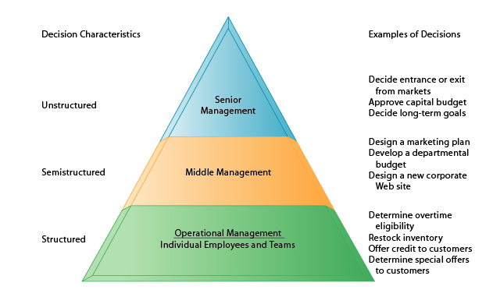

**Structured Decisions:** Structured decisions serve operational management, who are the individual employees, as well as teams. These are repetitive and involve a routine, with definitive procedures for solving. As a result, they do not need to be treated as new each time. Examples: Restocking inventory, determining special offers etc.

**Semistructured decisions:** Semistructured decisions serve middle management. These are structured but some elements are unstructured. Only part of the problem has a clear answer provided by accepted procedure. Examples: Designing a marketing plan, a new website etc.

**Unstructured decision:** The final type of decision is an unstructured decision, which serve senior management and do not have clear answers. These deicions require judgement, evaluation and insight to solve the problem. There is no set procedure for answering them. Examples: Entering a new market, obtaining a long-term loan etc.

Ans to the question no.4

A data warehouse is a database that stores current and historical data of potential interest to decision makers throughout the company. The data originate in several fundamental operational transaction systems, including those for sales, customer accounts, and production, and the data may also include information from transactions made on websites. Information from several operational databases is combined and standardized in the data warehouse so that it may be used throughout the organization for management analysis and decision-making.

The data warehouse makes the data available for anybody to access as needed, but it cannot be updated. A data warehouse system also includes a variety of ad hoc and standardized query tools, analytical tools, and graphical reporting capabilities. Many businesses employ internet portals to make data warehouse information widely available throughout the organization.

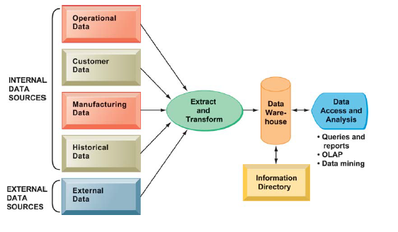

Above the diagram depicts how a data warehouse works. The data warehouse combines current and historical data from the organization's various operational systems. These data are merged with information from other sources and arranged into a central database for management reporting and analysis. The information directory informs users about the data available in the warehouse.

Ans to the question no.5

An input/output device, often known as an IO device, is any hardware that allows a human operator or other systems to interface with a computer. Input/output devices, as the name implies, are capable of delivering data (output) to and receiving data from a computer (input).

There are many IO Devices available, some of them are:

Input Devices

**Keyboard:** Principal method of data entry for text and numerical data.

**Mouse:** A hand-supported input device that allows users to move the cursor on the screen is a mouse. It works on a flat surface with a wheel between the left and right buttons. Laptops have a touchpad as does the function of a mouse.

**Touch screen:** A device that allows users to interact with a computer by touching the surface of a sensitive display panel. Used in airport kiosks, retail stores, and restaurants, as well as multitouch devices such as the iPhone, iPad, and multitouch PCs.

**Joy Stick:** It is a device which comprises a stick which is attached at an angle to the base so that it can be moved and controlled.Mostly used to control the movement in video games.

**Microphone:** Using a microphone, sound can be stored in a device in its digital form. It converts sound into an electrical signal.

**Scanner:** This device can scan images or text and convert it into a digital signal. When we place any piece of a document on a scanner, it converts it into a digital signal and displays it on the computer screen.

**Barcode Reader:** A kind of an optical scanner which can read bar codes. A source of light is passed through a bar code, and its aspects and details are displayed on the screen.

Output devices

**Monitor:** The device which displays all the icons, text, images, etc. over a screen is called the Monitor. When we ask the computer to perform an action, the result of that action is displayed on the monitor.

**Printer:** A device which makes a copy of the pictorial or textual content, usually over a paper is called a printer. For example, an author types the entire book on his/her computer and later gets a print out of it, which is in the form of paper and is later published.

**Speakers:** A device through which we can listen to a sound as an outcome of what we command a computer to do is called a speaker. Speakers are attached with a computer system and also are a hardware device which can be attached separately.