**Name: Nur Ahammad**

**Subject:** MAT-102

**Batch No: BBA 52**

**ID NO: 1121520011**

**Answer All Questions**

1. Let A ={a,b,c,d}, B ={b,d,e,f} and C = {a,c,g,h} Determine (i) A—B, (ii) B — C, (iii) B — B

Or

Discuss Different Types of Set

2. Let A = {a, b, c, d, e, f}. Find the power set P(A)

Or Discuss about De-Morgan's laws

3. Find the sum of the series 62 + 60 + 58 +...+ 40

Or Discuss About Geometric Progression

4. Find the sum of the series

122 + 120 + 116 + . . . + 80

Or

Discuss About Arithmetic Progression

**Ans to the question no. 1:**

**Different Types of Set :**

Set is a well-defined collection of Objects or items or data is known as a set. The objects or data are known as the element. For Example, the boys in a classroom can be put in one set, all integers from 1 to 100 can become one set, and all prime numbers can be called an Infinite set. The symbol used for sets is {…..}. Only the collection of data with specific characteristics is called a set.

**Types of Sets in Mathematics:**

Sets are the collection of different elements belonging to the same category and there can be different types of sets seen. A set may have an infinite number of elements, may have no elements at all, may have some elements, may have just one element, and so on. Based on all these different ways, sets are classified into different types. The different types of sets are:

**Singleton Set**

Singleton Sets are those sets that have only 1 element present in them.

**Example:**

* Set A= {1} is a singleton set as it has only one element, that is, 1.
* Set P = {a : a is an even prime number} is a singleton set as it has only one element 2.

Similarly, all the sets that contain only one element are known as Singleton sets.

**Empty Set**

Empty sets are also known as Null sets or Void sets. They are the sets with no element/elements in them. They are denoted as ϕ.

Advertisement

**Example:**

* Set A= {a: a is a number greater than 5 and less than 3}
* Set B= {p: p are the students studying in class 7 and class 8}

**Finite Set**

Finite Sets are those which have a finite number of elements present, no matter how much they’re increasing number, as long as they are finite in nature, They will be called a Finite set.

**Example:**

* Set A= {a: a is the whole number less than 20}
* Set B = {a, b, c, d, e}

**Infinite Set**

Infinite Sets are those that have an infinite number of elements present, cases in which the number of elements is hard to determine are known as infinite sets.

**Example:**

* Set A= {a: a is an odd number}
* Set B = {2,4,6,8,10,12,14,…..}

**Equal Set**

Two sets having the same elements and an equal number of elements are called equal sets. The elements in the set may be rearranged, or they may be repeated, but they will still be equal sets.

**Example:**

* Set A = {1, 2, 6, 5}
* Set B = {2, 1, 5, 6}

In the above example, the elements are 1, 2, 5, 6. Therefore, A= B.

**Equivalent Set**

Equivalent Sets are those which have the same number of elements present in them. It is important to note that the elements may be different in both sets but the number of elements present is equal. For Instance, if a set has 6 elements in it, and the other set also has 6 elements present, they are equivalent sets.

**Example:**

Set A= {2, 3, 5, 7, 11}

Set B = {p, q, r, s, t}

Set A and Set B both have 5 elements hence, both are equivalent sets.

**Subset**

Set A will be called the Subset of Set B if all the elements present in Set A already belong to Set B. The symbol used for the subset is **⊆**

If A is a Subset of B, It will be written as A ⊆ B

**Example:**

Set A= {33, 66, 99}

Set B = {22, 11, 33, 99, 66}

Then, Set A ⊆ Set B

**Power Set**

Power set of any set A is defined as the set containing all the subsets of set A. It is denoted by the symbol **P(A)** and read as Power set of A.

For any set A containing n elements, the total number of subsets formed is 2n. Thus, the power set of A, P(A) has 2n elements.

**Example: For any set A = {a,b,c}, the power set of A is?**

**Solution:**

Power Set P(A) is,

P(A) = {ϕ, {a}, {b}, {c}, {a, b}, {b, c}, {c, a}, {a, b, c}}

**Universal Set**

A universal set is a set that contains all the elements of the rest of the sets. It can be said that all the sets are the subsets of Universal sets. The universal set is denoted as U.

**Example**: **For Set A = {a, b, c, d} and Set B = {1,2} find the universal set containing both sets.**

**Solution:**

Universal Set U is,

U = {a, b, c, d, e, 1, 2}

**Disjoint Sets**

For any two sets A and B which do have no common elements are called Disjoint Sets. The intersection of the Disjoint set is ϕ, now for set A and set B A∩B =  ϕ.

**Example: Check whether Set A ={a, b, c, d} and Set B= {1,2} are disjoint or not.**

**Solution:**

Set A ={a, b, c, d}  
Set B= {1,2}

Here, A∩B =  ϕ

Thus, Set A and Set B are disjoint sets.

**Ans to the question no. 2:**

**De-Morgan's law:** De Morgan's Law consists of a pair of transformation rules in boolean algebra that is used to relate the intersection and union of sets through complements. There are two conditions that are specified under Demorgan's Law. These conditions are primarily used to reduce expressions into a simpler form. This increases the ease of performing calculations and solving complex boolean expressions.

According to De Morgan's Law, the complement of the union of two sets will be equal to the intersection of their individual complements. Additionally, the complement of the intersection of two sets will be equal to the union of their individual complements. These laws can easily be visualized using Venn diagrams. In this article, we will learn about the statements of Demorgan's Law, the proof of these statements, their applications, and examples. Demorgan's laws are a set of two postulates that are widely used in set theory. When we have a collection of well-defined distinct objects that form a group, this collection is known as set. If we want to simplify set operations such as taking the complement, union, and intersection of sets, then we use De Morgan's laws.

### De Morgan's Law Statement

Demorgan's law can be used in boolean algebra as well as in set theory to simplify mathematical expressions. Suppose we have two sets A and B that are [subsets](https://www.cuemath.com/algebra/subsets/) of the [universal set](https://www.cuemath.com/algebra/universal-set/) U. A' is the complement of A and B' is the complement of set B. '∩' is the symbol for intersection and '∪' is used to denote the union. Then the De Morgan's laws are given below.

**De Morgan's Law of Union:** The complement of the union of the two sets A and B will be equal to the intersection of A' (complement of A) and B' (complement of B). This is also known as De Morgan's Law of Union. It can be represented as (A ∪ B)’ = A’ ∩ B’. We can also generalize this law. Suppose we have n sets given by {A1,A2,...,An

} then formula is given by (⋃ni=1Ai)′=⋂ni=1A′i

.

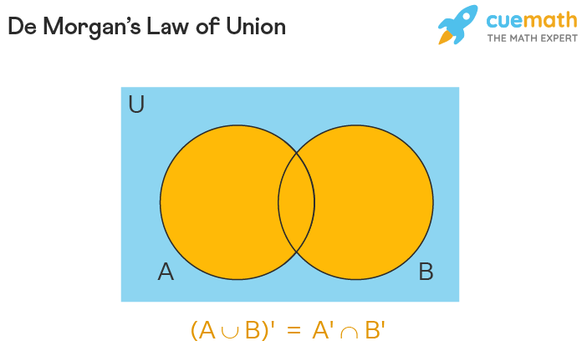

**De Morgan's Law of Intersection:** The complement of the intersection of A and B will be equal to the union of A' and B'. This condition is called De Morgan's law of Intersection. It can be given by (A ∩ B)’ = A’ ∪ B’. Similarly, as above this law can be generalized by the formula (⋂ni=1Ai)′=⋃ni=1A′i

.

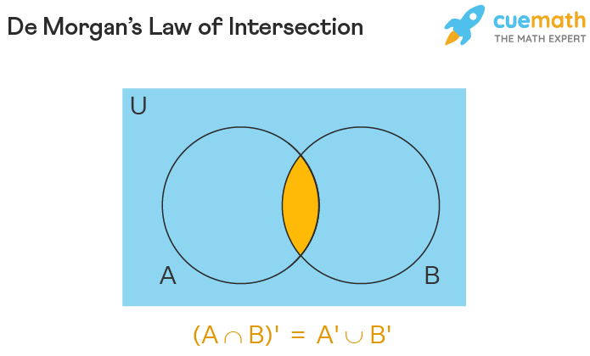

### De Morgan's Law Example

Let us understand De Morgan's Law with the help of a simple example. Let the universal set U = {7, 8, 9, 10, 11, 12, 13 }. The two subsets are given by A = {11, 12, 13} and B = {7, 8}.

De Morgan's Law of Union Example: (A ∪ B) = {7, 8, 11, 12, 13}, (A ∪ B)’ = {9, 10}. A’ = {7, 8, 9, 10} and B' = { 9, 10, 11, 12, 13}. A’ ∩ B’ = {9, 10}. Thus, (A ∪ B)’ = A’ ∩ B’

De Morgan's Law of Intersection Example: (A ∩ B) = ∅, (A ∩ B)' = {7, 8, 9, 10, 11, 12, 13 }. A’ ∪ B’ = {7, 8, 9, 10, 11, 12, 13}. Hence, (A ∩ B)’ = A’ ∪ B’

## De Morgan's Law Proof

In set theory, Demorgan's Law proves that the intersection and union of sets get interchanged under complementation. We can prove De Morgan's law both mathematically and by taking the help of truth tables.

The first **De Morgan's theorem** or Law of Union can be proved as follows:

Let R = (A U B)' and S = A' ∩ B'. Suppose we choose an element y that belongs to R. This is denoted as y ∈ R.

⇒ y ∈ (A U B)'

⇒ y ∉ (A U B)

⇒ y ∉ A and y ∉ B

⇒ y ∈ A' and y ∈ B'

⇒ y ∈ A' ∩ B'

⇒ y ∈ S

Thus, we conclude that R ⊂ S (R is a subset of S) ...(1)

Now suppose we have an arbitrary element z that belongs to set S. Then z ∈ S

⇒ z ∈ A' ∩ B'

⇒ z ∈ A' and z ∈ B'

⇒ z ∉ A and z ∉ B

⇒ z ∉ (A U B)

⇒ z ∈ (A U B)'

⇒ z ∈ R

Hence, S ⊂ R ...(2)

From (1) and (2) we infer that S = R or (A ∪ B)’ = A’ ∩ B’. Thus, this theorem is proved.

The second De Morgan's theorem or law of Intersection can be mathematically proved using the following steps:

Let G = (A ∩ B)' and H = A' U B'

Let an element y belong to G. y ∈ G.

⇒ y ∈ (A ∩ B)'

⇒ y ∉ (A ∩ B)

⇒ y ∉ A or y ∉ B

⇒ y ∈ A' or y ∈ B'

⇒ y ∈ A' U B'

⇒ y ∈ G

This implies that G ⊂ H ...(1)

If z is an arbitrary element of H then z ∈ H

⇒ z ∈ A' U B'

⇒ z ∈ A' or z ∈ B'

⇒ z ∉ A or z ∉ B

⇒ z ∉ (A ∩ B)

⇒ z ∈ (A ∩ B)'

⇒ z ∈ H

Therefore, H ⊂ G ...(2)

Now when we combine (1) and (2) we can say that G = H or (A ∩ B)’ = A’ ∪ B’. Hence, we have successfully proved the second theorem.

### De Morgan's Law Truth Table

In boolean algebra, we make use of logic gates. These logic gates work on logic operations. Here, A and B become input binary variables. "0's" and "1's" are used to represent digital input and output conditions. Thus, using these conditions we can create truth tables to define operations such as AND (A•B), OR (A + B), and NOT (negation). By using logic operations as well as truth tables, we can state and prove De Morgan's laws as follows:

First De Morgan's Law states that when two or more input variables (A, B) are OR’ed and then negated, the result is equal to the AND of the complements of the individual input variables. ¯¯¯¯¯¯¯¯¯¯¯¯¯¯¯A+B

= ¯¯¯¯A•¯¯¯¯B

. To prove this theorem we can use the truth table as given below:

|  |  |  |  |  |  |  |
| --- | --- | --- | --- | --- | --- | --- |
| INPUTS | | OUTPUTS | | | | |
| B | A | A + B | ¯¯¯¯¯¯¯¯¯¯¯¯¯¯¯A+B |  |  |  |

|  |  |
| --- | --- |
|  | ¯¯¯¯A |

|  |  |
| --- | --- |
|  | ¯¯¯¯B |

|  |  |
| --- | --- |
|  | ¯¯¯¯A |

. ¯¯¯¯B

|  |
| --- |
|  |
| 0 | 0 | 0 | 1 | 1 | 1 | 1 |
| 0 | 1 | 1 | 0 | 0 | 1 | 0 |
| 1 | 0 | 1 | 0 | 1 | 0 | 0 |
| 1 | 1 | 1 | 0 | 0 | 0 | 0 |

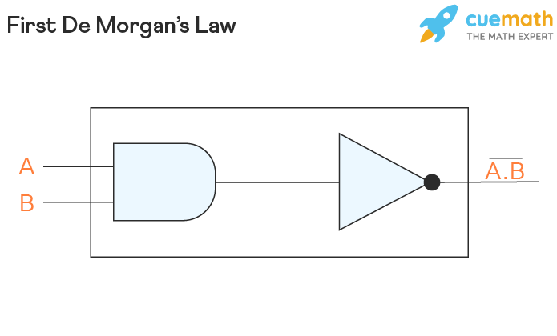

Second De Morgan's Law states that when two or more input variables are AND'ed and negated, then the obtained result will be equal to the OR of the complements of the individual variables. ¯¯¯¯¯¯¯¯¯¯¯¯¯A∙B

= ¯¯¯¯A + ¯¯¯¯B

. Using the truth table, we can prove this as follows:

|  |  |  |  |  |  |  |
| --- | --- | --- | --- | --- | --- | --- |
| INPUTS | | OUTPUTS | | | | |
| B | A | A•B | ¯¯¯¯¯¯¯¯¯¯¯¯¯A∙B |  |  |  |

|  |  |
| --- | --- |
|  | ¯¯¯¯A |

|  |  |
| --- | --- |
|  | ¯¯¯¯B |

|  |  |
| --- | --- |
|  | ¯¯¯¯A |

+ ¯¯¯¯B

|  |
| --- |
|  |
| 0 | 0 | 0 | 1 | 1 | 1 | 1 |
| 0 | 1 | 0 | 1 | 0 | 1 | 1 |
| 1 | 0 | 0 | 1 | 1 | 0 | 1 |
| 1 | 1 | 1 | 0 | 0 | 0 | 0 |

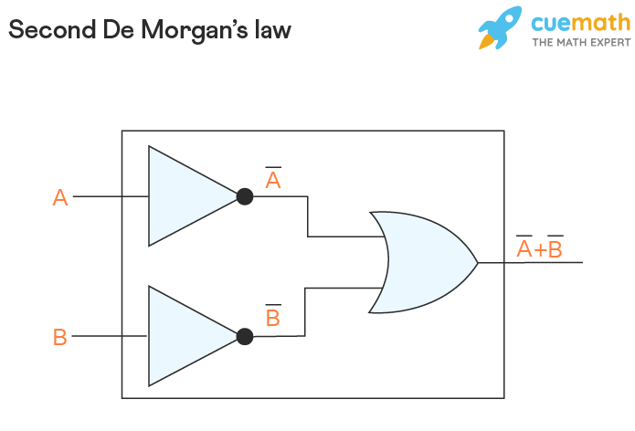

For simplicity purposes, OR operation is analogous to the union of sets operation while the AND operation corresponds to the intersection operation of sets.

## De Morgan's Law Formula

Demorgan's Law is used both in set theory as well as in boolean algebra. These laws are critical in understanding mathematical arguments. Using these laws a relationship can be established between union and intersection via complementation. Given below are the various forms of the formulas:

In set theory,

* (A ∪ B)’ = A’ ∩ B’
* (A ∩ B)’ = A’ ∪ B’

Generalized Formulas for infinite unions and intersections,

* (⋃ni=1Ai)′=⋂ni=1A′i

• (⋂ni=1Ai)′=⋃ni=1A′i

In Boolean Algebra,

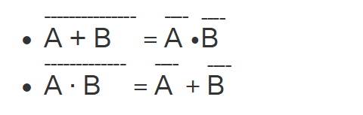

## Applications of De Morgan's Law

De Morgan's law is used in both elementary algebra as well as Boolean algebra. As this law helps to reduce complicated expressions it is widely utilized in most engineering industries to create hardware and simplify operations. Given below are some other applications of De morgan's law.

* De morgan's law applications can be seen in electronic engineering for developing logic gates. By using, this law equations can be constructed using only the NAND (AND negated) or NOR (OR negated) gates. This results in cheaper hardware. Further, NAND, NOT and NOR gates are easier to implement practically.
* Demorgan's law is used in computer programming. This law helps to simplify logical expressions written in codes thereby, reducing the number of lines. Thus, it helps in the overall optimization of the code. Furthermore, these laws are make verifying SAS codes much simpler and faster.

**Ans to the question no. 3:**

**Geometric Progression:** Geometric Progression (GP) is a specific type of progression or sequence, where each next term in the progression is produced by multiplying the previous term by a fixed number, and the fixed number is called the Common Ratio. Similar to arithmetic progression, geometric progression also carries a specific pattern that is useful in dealing with GP questions. Common ratio and the first term of a GP is always a non-zero number.

Example: 3,6,12,24,48, and so on is a GP with first term 3 and common difference 2.

A geometric sequence is one in which the ratio between two consecutive terms is constant. This ratio is known as the common ratio denoted by ‘r’, where r ≠ 0. Let the elements of the sequence be denoted by:

 a1, a2, a3, a4, …, an

Given sequence is a geometric sequence if:

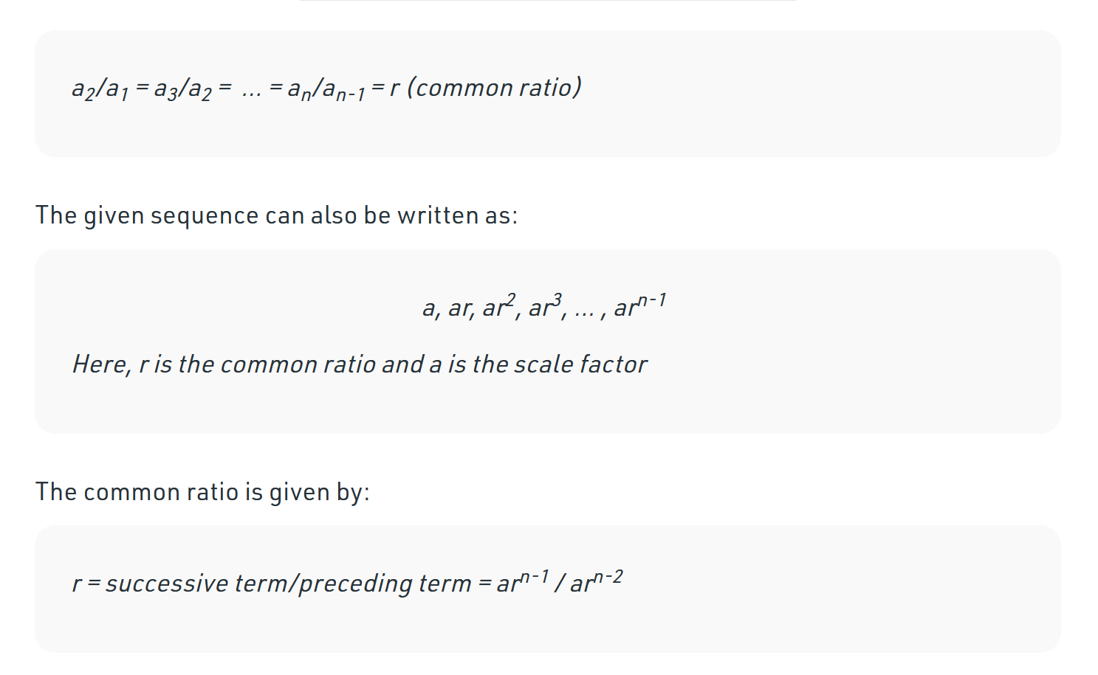

**Types of Geometric Progression**

Geometric progression is further classified on the basis of whether they are ending or continuing infinitely. So, a GP is further classified into two parts which are:

Finite Geometric Progression (Finite GP)

Infinite Geometric Progression (Infinite GP)

**Ans to the question no. 4:**

**Arithmetic Progression:**

In the field of mathematics, Arithmetic Progression, or what is commonly referred to as AP, is a sequence of numbers in a specific or particular order. In our day-to-day lives, we come across quite a few examples of progression, that too, frequently. For instance - the roll numbers of a class, months in a year, days in a week, and so on.

In mathematics, the pattern of sequences and series has been generalized and is known as progressions. So, let us make ourselves familiar with what is an arithmetic progression along with the terms widely used under this concept, including the first term of the series, common difference, nth term, etc.

**What is Arithmetic Progression?**

A progression refers to an exclusive type of sequence for which we can find and obtain the formula for the nth term. In mathematics, the most commonly used sequence is that of an Arithmetic Progression or AP and has formulae that are quite easy to understand. The concept of AP can be understood using three different definitions, which are as follows:

* **Definition 1:** An Arithmetic Progression or AP is a mathematical sequence having a constant difference between two consecutive terms.
* **Definition 2:** An Arithmetic Progression or AP is a sequence of numbers in which the second number can be obtained by adding a constant or fixed number to the first one for every pair of consecutive terms.
* **Definition 3:** The fixed or constant number that is added to any term of an Arithmetic Progression or AP to obtain its next term is called the 'common difference' of AP.

**Understanding the Concepts of Common Difference and First Term**

In an Arithmetic Progression or AP, for a given series or sequence, the widely used terms include the first term of AP, its common difference, and the nth term.

Let us suppose that the sequence

*a*1,*a*2,*a*3,*a*4,...*an*

is an AP.

We can obtain the common difference, 'd' using the formula mentioned below:

*d*=*a*2−*a*1=*a*3−*a*2=*a*4−*a*3=*an*−*an*−1

, where 'd' refers to the common difference, and it can be positive, negative, or zero.

In terms of the common difference, the Arithmetic Progression can be expressed or written as:

*a*,*a*+*d*,*a*+2*d*,*a*+3*d*......*a*+(*n*−1)*d*

, where 'a' refers to the first term of an AP.

**How to find the nth of an Arithmetic Progression or AP?**

For finding the nth term of an Arithmetic Progression or AP, the formula is:

an= a + (n - 1)d, where

‘a’ is the first term, d is a common difference, n refers to the number of terms, and an= nth term.

It is imperative to make a point of the fact that the sequence of an Arithmetic Progression depends on its common difference, that is, d.

If the common difference or d is positive, then the terms of an AP will grow towards the positive side of infinity. On the other hand, if the common difference or d is negative, then the terms of AP will grow towards the negative side of infinity.

**How to find the sum of the first n terms of an Arithmetic Progression or AP?**

For finding the sum of the first n terms of an Arithmetic Progression or AP, the formula is:

*S*=*n*2(2*a*+(*n*−1)×*d*)

, where

a is the first term, d is a common difference, n refers to the number of terms, and S is the sum of the first n term of an AP.

**Formulae for Arithmetic Progression**

For solving the mathematical problems based on the series and sequences of an AP, it is essential to know, understand, and learn the formulae specified below:

* **General Form of an Arithmetic Progression or AP**

a, a + d, a + 2d, a + 3d......a + (n - 1)d

* **nth Term of an Arithmetic Progression or AP**

an= a + (n - 1)d

* **Sum of n Terms of an Arithmetic Progression or AP**

*S*=*n*2(2*a*+(*n*−1)×*d*)

,

* Sum of all Terms of a Finite Arithmetic Progression or AP, when its first and last terms are known:

*n*2

(a + l), where 'a' is the first term, and 'l' is the last term.

* **Common difference of AP**

d = a2- a1 or d=an-an-1 where a1 is the first term and a2 is the second term. Similarly, an is the last term and an-1 is the last but one term.