**Name: Nur Ahammad**

**Subject:** ACT-217

**Batch No: BBA 52**

**ID NO: 1121520011**

**Answer All:**

1. Describe the concept of time value of money. What are the techniques used in time value of money?

2. Write notes short • EAR • Discounting • Compounding • Annuity • Amortization Schedule

3. Mr. JinPi wants to invest in a bank now with $5,00,000 at 8% annual interest. If investment is made for 10 years, what will be value of the investment after the period.

4. If company A: invests $300,000 and B: invests $4,00,000 in two new production lines, and the production lines then produce positive cash flow of $100,000 and $1,05,000 per year. Compute payback period and mention which one is acceptable?

**Ans to the question no. 1:**

**Ans: Concept of time value of money**: Time Value of Money (TVM) is a fundamental financial concept, stating that the current value of money is higher than its future value, given its potential to earn in the years to come. Thus, it suggests that a sum of money in hand is greater in value than the same sum of money received in the next couple of years. It’s is the idea that money today is worth more than that same money in the future because of its interest-earning potential. For example, if an employer or a client gives me an option for your income. I can either receive $12,000 now, or $1,200 monthly for the next 10 months. By understanding the time value of money, I can weigh the opportunity for growth against the consistency of recurring payments.

If i forego the opportunity to collect and invest the money, I could lose earnings, or the client could suddenly disappear after paying only four installments. Because of the uncertainty of the future — in addition to the interest-earning potential and inflation — current dollars are worth more than future dollars.

**Following techniques used in time value of money:**

1. **Present value calculations**

One common time-value problem deals with expecting a specified sum of money at a point in the future. Because money earned in the future is worth less than money earned now, you have to apply a discount to the future payment in order to get its equivalent present value. Often, the discount rate used is equal to the prevailing risk-free rate for assets like Treasury securities without default risk. The further into the future the payment is, the greater the discount.

The math behind a present value calculation is a bit complicated but can be done with a basic calculator. To come up with present value, take 1 and add it to the discount rate used. Then raise that number to the power of the number of years in the future that you'll receive the payment. Save the resulting figure, and then divide the future payment amount by that figure. The final result will be the present value.

For instance, say you know that you'll receive $110.25 in two years and decide that a discount rate of 5% is appropriate. In that case, 1 plus 5% equals 1.05, and 1.05 raised to the second power is 1.1025. Divide $110.25 by 1.1025, and you get $100, which is the present value.

1. **Future value calculations**

Future value calculations work in the opposite manner. You'll follow the same steps as you did for present value, adding 1 to the discount rate and then raising that number to the power of the number of years in the future that you're measuring the future value. But then, you'll need to multiply the result by the value of the current payment. The final result is the future value. For instance, if you want to know the future value of $100 in two years assuming a rate of 5%, then 1 + 5% is 1.05, 1.05 raised to the second power is 1.1025, and $100 multiplied by 1.1025 is $110.25. As you can see, this matches up with the present value calculation above.

1. **Recurring value techniques**

The two methods discussed above work well for one-time payments, but other methods are better for recurring payments. You can always just calculate present or future value for each payment separately, but there are sometimes shortcuts available for common situations. For instance, say you have an asset that pays a perpetual stream of income. You can't calculate each payment separately, but the equation for its present value turns out to be quite simple: take the amount of each regular payment and divide it by the discount rate. So if you receive $100 each year and use a discount rate of 5%, then its present value is $100 / 5% = $2,000. Knowing how to deal with time-value problems can save a lot of time and make it easier to compare streams of future payments. That way, we can make smarter decisions about money.

**Ans to the question no. 2:**

**Short Notes:**

**1. EAR:**

**The Effective Annual Interest Rate (EAR)** is the interest rate that is adjusted for compounding over a given period. Simply put, the effective annual interest rate is the rate of interest that an investor can earn (or pay) in a year after taking into consideration compounding. EAR can be used to evaluate interest payable on a loan or any debt or to assess earnings from an investment, such as a guaranteed investment certificate (GIC) or savings account. The effective annual interest rate is also known as the effective interest rate (EIR), annual equivalent rate (AER), or effective rate. Compare it to the Annual Percentage Rate (APR) which is based on simple interest.

The EAR formula is given below:



Where

* **i** = Stated annual interest rate
* **n** = Number of compounding periods

**2. Discounting**:

In relation to the time value of money, which argues that a dollar today is worth more than a dollar tomorrow, discounting can be defined as the act of estimating the present value of a future payment or a series of cash flows that are to be received in the future. Discounting is a key element in valuing future cash flows. An investor expects their investment to show some liquidity in terms of positive cash flow during its financial performance. While these cash flows are expected in the future, the present value can be calculated to understand these future cash flows. A discount rate is applied to future cash flows to determine the present value. This is what discounting in finance is all about.

The discounting definition is converting the value of future cash flows into their present value. The value of a dollar today will not be the same as tomorrow, and it is, in fact, worth more today than tomorrow. This is because money earned in the future is less valuable than the one today. Discounting allows proper valuation of future money by converting it to today's value using a discount rate.

Discounting Formula:

The discounting formula uses the discount rate to calculate the net present value or NPV. The determination of the NPV of an investment is crucial because it gives the difference between the values of the initial investment (capital outlay) and the current value of the future cash flows from the investment. If the NPV result is positive, the future cash flows will reap some gains, and there will be profits for the investors and businesses. If the result is negative, it will show that the expectations were not met and there is a loss on the investment.

The discounting formula for NPV is given as follows:

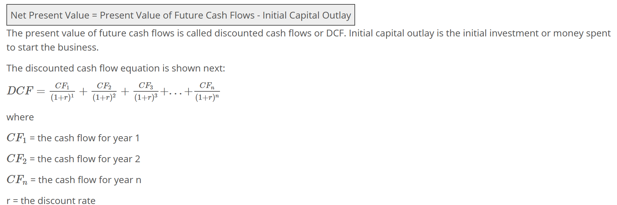

**3. Compounding:**

Compounding is a term used in different disciplines and fields of study. In the context of investment, compounding is a financial term that describes the ability of an asset or security to generate more earnings when reinvested. Investors make investments to make profits, oftentimes, when earnings are made on an asset or security, investors seek to reinvest the earnings in order to receive more earnings. The earnings that can be made on an asset can either be through interests of capital gains, when the earnings are reinvested and they also yield returns, the compounding effect has taken place. The compounding effect is due to both the principal investment and the earnings yielding returns during a particular time.

In contrast Linear growth pf an asset is different from compound growth, in linear growth, only the principal yields interest or returns while in compound growth, both the principal and accumulated earnings yield returns. Usually, compounding helps investors grow their money faster than linear growth. When compound interest takes effect, an investor earns interest on both his principal and accumulated earnings. For instance, if an investor holds a sum of $50,000 in an account that yields a 10% interest annually, this means that $5,000 will be paid as interest in a year. Instead of withdrawing the interest earned, the investor can reinvest the $5,000 earning which will also attract an interest of $500. This can be done for a period of time, this pattern is referred to as compounding.

**4. Annuity:**

An annuity is a reasonable alternative to some other investments as a source of income since it provides guaranteed income to an individual. However, annuities are less liquid than investments in securities because the initially deposited lump sum cannot be withdrawn without penalties.

Upon the issuance of an annuity, an individual pays a lump sum to the issuer of the annuity (financial institution). Then, the issuer holds the amount for a certain period (called an accumulation period). After the accumulation period, the issuer must make fixed payments to the individual according to predetermined time intervals.

Annuities are primarily bought by individuals who want to receive stable retirement income.

**Types of Annuities**

There are several types of annuities that are classified according to frequency and types of payments. For example, the cash flows of annuities can be paid at different time intervals. The payments can be made weekly, biweekly, or monthly. The primary types of annuities are:

a. Fixed annuities

b. Variable annuities

c. Life annuities

d. Perpetuity

**5. Amortization Schedule**The Amortization schedule is a very common way to break down the loan amount in the interest and the principal. Most people think that by making a minimum payment for their loan, they lower the principal amount. This depends on the duration of the loan.

For example, in the beginning of the term for a long-term loan, most of the payment goes towards lowering the interest. As the term progresses, a greater percentage of the payment goes to the principal and a lower percentage goes to the interest. So, people who want to pay off their loan fast, make extra payments in the beginning of the term. A loan amortization schedule is a table that shows each periodic loan payment that is owed, typically monthly, for level-payment loans. The schedule breaks down how much of each payment is designated for the interest versus the principal. Loan amortization tables can help a borrower keep track of what they owe and when payment is due, as well as forecast the outstanding balance or interest at any point in the cycle. Loan amortization schedules are often seen when dealing with installment loans that have known payoff dates at the time the loan is taken out. Examples of amortizing loans include mortgages and car loans.

**Ans to the question no. 3:**

### **Future Value Formula**

The formula for calculating the Future Value is-

**Future Value (FV) = PV × (1 + r) ^ n**

Where:

PV = Present Value

r = Interest Rate (%)

n = Number of Compounding Periods

The value of the investment after the period will be 1,079,462

**Ans to the question no. 4:**

Payback Period = Initial Investment / Yearly Cash Flow

Company A Payback Period=300000/100000

Company A Payback Period=3 years payback period

Company B Payback Period=400000/105000

Company B Payback Period = 3.81s year payback period

Note: Since the company A has a shorter payback period, this may be a better choice for the company.