**Name: Nur Ahammad**

**Subject:** ACT-214

**Batch No: BBA 52**

**ID NO: 1121520011**

**Answer All:**

1. Explain the concept of financial statement.

2. Discuss different categories of financial statements.

3. i) Current Ratio, ii) Liquidity Ratio

4. Suppose you're financial manager of Jinping Corporation. You've to analyze financial performance on- Liquidity Ratio, Working capital ratio from the given financial position statement

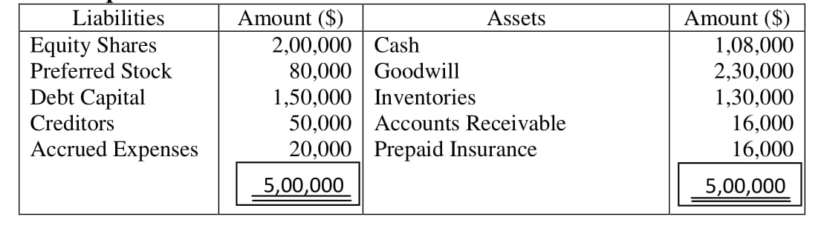

**Ans to the question no. 1:**

**Ans:** Concept of financial statement:

Financial statements are a key tool for running a business. They’re a snapshot of your company’s finances and give crucial information about your business performance. They’re also the foundation for planning future course.

Financial statements are also used by bankers, investors and others to assess the health and liquidity of your business and make decisions that affect it.

Financial statements are a set of documents that show your company’s financial status at a specific point in time. They include key data on what your company owns and owes and how much money it has made and spent.

**There are four main financial statements:**

**1. Balance sheet:** The balance sheet shows what the company owns and how much it owes at the end of the period. It is based on the equation: Assets = Liabilities + Shareholders’ Equity

**2. Income statement:** An income statement shows the profitability of your business. It details how much money your business earned and spent. The income statement is also sometimes referred to as a profit-loss statement or an earnings statement.

It shows:

* Revenue from selling products or services
* Expenses to generate the revenue and manage your business
* Net income (or profit) that remains after your expenses

**3. Cash flow statement**: The cash flow statement, sometimes called a statement of changes in financial position, shows how money has moved through your business during the period.

**4. Statement of retained earnings:** The statement of retained earnings shows the cumulative earnings of the business after any dividends or distributions to shareholders. As well, this statement, sometimes called a statement of changes in equity, also shows the change in the retained earnings account between the opening and closing periods on each balance sheet.

**Ans to the question no. 2:**

Discuss different categories of financial statements:

**There is 4 Categories of Financial Statements That Every Business Needs which has been discussed discussed below:**

It's important for the small business owner to understand these four types of financial statements and the information they provide for the investor or creditor interested in providing funds for your business.

Both individually and taken together, these financial statements give a potential investor or creditor a wealth of information and can have a serious impact on your business's ability to obtain the funds or financing it needs.

Also known as a statement of financial position, or a statement of net worth, the balance sheet is one of the four important financial statements every business needs.

**1. Balance Sheet**

Also known as a statement of financial position, or a statement of net worth, the balance sheet is one of the four important financial statements every business needs. It also provides users with a look at the business's financial position at a specific point in time, and financial statement analysts use the information it contains to calculate several important financial ratios.

**2. Income Statement**

The income statement is another important financial statement for your small business. It provides users with a picture of the business's financial performance over a specific period of time.

Also known as a statement of revenue and expense, or a profit and loss statement (P&L), the income statement is a statement of earnings that shows a business's operating and nonoperating revenue and expenses.

Like the balance sheet, the information contained in an income statement is used in financial statement analysis to calculate financial ratios that provide users with further insight into a business's financial performance.

**3. Cash Flow Statement**

The cash flow statement, also known as a statement of cash flows, or a statement of changes in financial position, is an important financial statement that gives users an understanding of how well a business is managing its cash flow.

Using the information in a cash flow statement, users are able to see whether a business is generating sufficient cash to meet both its debt obligations and its operating expenses.

The typical cash flow statement format provides information about a business's cash from operating activities, cash from investing activities, and cash from financing activities.

**4. Statement of Owner's Equity**

The fourth financial statement that a business needs is a statement of owner's equity, also known as a statement of changes in equity, or a statement of shareholders' equity. Retained earnings are often used to either reinvest in the company, or to pay off the business's debt obligations. It provides users with information regarding the financial health of a business, as it shows whether the business is capable of meeting ongoing financial and operating obligations without requiring its owners to contribute more capital. By preparing each of these financial statements, not only will you be able to provide a prospective investor or creditor with important information that they need to assess your business, but also you will be able to identify trends in your business's performance that will help you to position your business for continued success.

**Ans to the question no. 3:**

Ans:

**i.Current Ratio**

The current ratio is a liquidity ratio that measures a company’s ability to pay short-term obligations or those due within one year. It tells investors and analysts how a company can maximize the current assets on its balance sheet to satisfy its current debt and other payables.

A current ratio that is in line with the industry average or slightly higher is generally considered acceptable. A current ratio that is lower than the industry average may indicate a higher risk of distress or default. Similarly, if a company has a very high current ratio compared with its peer group, it indicates that management may not be using its assets efficiently.

The current ratio is called current because, unlike some other liquidity ratios, it incorporates all current assets and current liabilities. The current ratio is sometimes called the working capital ratio.

**Example**:

Using the Balance Sheet, the current ratio is calculated by dividing current assets by current liabilities:

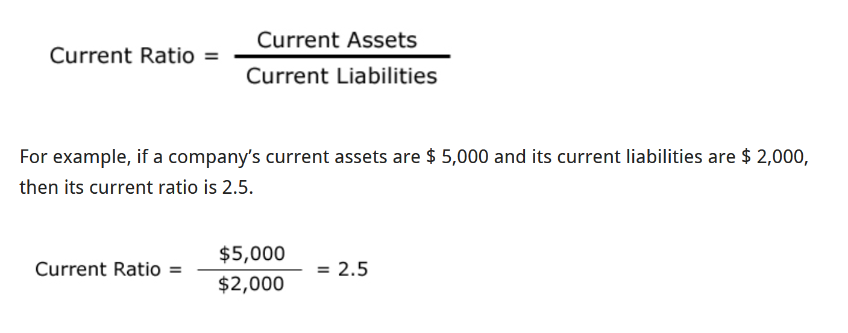

**ii) Liquidity Ratio**

A liquidity ratio is a type of financial ratio used to determine a company’s ability to pay its short-term debt obligations. The metric helps determine if a company can use its current, or liquid, assets to cover its current liabilities. Liquidity is a very critical part of a business. Liquidity is required for a business to meet its short-term obligations. Liquidity ratios are a measure of the ability of a company to pay off its short-term liabilities.

Liquidity ratios determine how quickly a company can convert the assets and use them for meeting the dues that arise. The higher the ratio, the easier is the ability to clear the debts and avoid defaulting on payments.

Liquidity ratios tell you about a company’s ability to meet all its financial obligations, including debt, payroll, payments to vendors, taxes, and so on. The numbers come from the Balance Sheet. The current ratio is one of the liquidity ratios. It measures a company’s ability to pay its short-term obligations. The current ratio looks at current assets (those that can be converted to cash in less than a year) and current liabilities (those that will have to be paid off in less than a year).

**Ans to the question no. 4:**

**Ans:**

**Current Ratio/ working capital** **ratio** = Current Assets / total current liabilities

500000÷500000=1

So Working Capital Ratio is 1:1

**Quick Ratio** = (Cash + Accounts Receivables + Marketable Securities) / Current Liabilities

(108000+16000+130000) ÷500000=0.508

**Cash Ratio** = (Cash + Marketable Securities) / Current Liabilities

(108000+130000)÷500000=0.476