**Name: Nur Ahammad**

**Subject:** BUS-212

**Batch No: BBA 52**

**ID NO: 1121520011**

**_______________________________________________________________________**

Answer any 4 Questions from the following: (4*10=40)

1) What is known as Communication? Explain the process of Communication.

2) Differentiate between verbal and non-verbal communication.

3) Write short notes from the following: Beliefs, Environment, Feelings, Values, Past Experience.

4) What have you done to improve your communication skills with people around you? Why having good communication skills are necessary to get success of business? Explain them.

5) What do you know about Visual Representation system? Describe.

6) Define the term Rapport. What are the different steps to build Rapport?

7) What are the importance of an effective communication in Business? Explain with proper examples.

**Ans to the question no. 1:**

Communication can best be summarized as the transmission of a message from a sender to a receiver in an understandable manner. The importance of effective communication is immeasurable in the world of business and in personal life. From a business perspective, effective communication is an absolute must, because it commonly accounts for the difference between success and failure or profit and loss. It has become clear that effective business communication is critical to the successful operation of modern enterprise. Every business person needs to understand the fundamentals of effective communication.

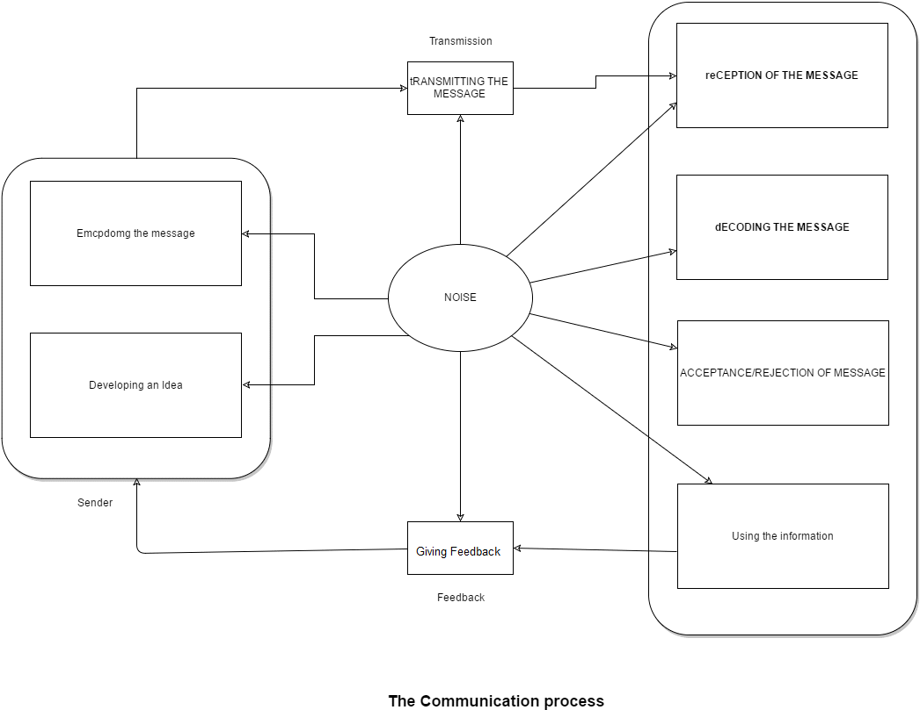

**Process # 1. Sender:**

Communication starts with the sender, who is the initiator of the message. After generating an idea, the sender encodes it in a way that can be comprehended by the receiver. Encoding refers to the process by which the sender translates his thoughts into a series of verbal and non-verbal actions that he feels will communicate the message to the intended receiver. For example, translating the thought into any language.

**Process # 2. Transmission:**

The information that the sender wants to communicate is transmitted over a channel through which the message travels to the receiver. A channel connects the sender to the receiver. Channels for communication may include a memorandum, a computer, a telephone, a telegram, or a television.

The choice of a channel depends on the communication situation. For instance, when dealing with confidential information, direct face-to-face interaction or a sealed letter are more effective channels than a telephone conversation.

**Process # 3. Noise:**

Noise is anything that has a disturbing influence on the message. Since noise hinders communication, the sender should choose a channel that is free from noise. Noise may occur at the sender’s end, during transmission, or at the receiver’s end.

Examples of noise include:

i. Ambiguous symbols that lead to faulty encoding

ii. A poor telephone connection

iii. An inattentive receiver

iv. Faulty decoding (attaching the wrong meaning to the message)

v. Prejudices obstructing the poor understanding of a message

vi. Gestures and postures that may distort the message

**Process # 5. Receiver:**

The receiver is the person to whom the message is transmitted. In order to decode the message, the receiver has to be ready to receive the message. That is. the receiver should not be preoccupied with other thoughts that might cause him to pay insufficient attention to the message. Decoding refers to the process of translation of symbols encoded by the sender into ideas that can be understood.

Communication can be considered effective only when both the sender and the receiver attach similar meanings to the symbols that compose the message. For example, a message in technical jargon requires a recipient who understands such terms. Communication is not complete unless it is understood by both the sender and the receiver.

**Process # 6. Feedback:**

A message generated by the receiver in response to the sender’s original message is known as feedback. Feedback is necessary to ensure that the message has been effectively encoded, transmitted, decoded and understood.

It helps a sender evaluate the effectiveness of his message, so that he can modify his subsequent messages. Feedback also confirms whether there has been any change in the behavior of the individual or in the organization as a result of communication.

The communication model discussed above provides the basic framework of the communication process, identifies the key elements (sender, transmission, receiver, noise and feedback), and shows their relationships. This framework helps managers pinpoint communication.

**Ans to the question no. 2:**

**Verval communication**: It is a type of communication where the sender uses words whether written or spoken to convey the message to the receiver. Verbal communication is the most common mode of communication and it normally results in immediate feedback. The chances of misunderstanding the information are quite a few since the message is clear and concise.

**Non-verbal communication:** It is a type of communication that involve the use of body gestures, sign language and facial expressions to transmit information. There are high chances of misunderstanding the information. But the form of communication tends to complement verbal communication.

**Main Difference between Verbal and Non-Verbal Communication**

1. Verbal communication involves the use of words and language whereas non-verbal communication involves the use of sign language and body gestures.
2. Non-verbal communication requires the physical presence of the sender and receiver whereas verbal communication does not need the physical presence of sender and receiver.
3. Verbal communication message is a clear and concise whereas non-verbal message in complex and difficult to understand.
4. Verbal communication tend to be fast and there is immediate feedback whereas non-verbal communication is comparatively low and time-consuming.
5. Verbal communication document evidence for future use whereas non-verbal communication does not document evidence.
6. Verbal communication tend to be structured whereas non-verbal communication is not structured.

**Ans to the question no. 6:**

**What is Rapport**: Rapport forms the basis of meaningful, close and harmonious relationships between people. It's the sense of connection that you get when you meet someone you like and trust, and whose point of view you understand. It's the bond that forms when you discover that you share one another's values and priorities in life.

According to researchers Linda Tickle-Degnen and Robert Rosenthal, when you have a rapport with someone, we share:

**Mutual attentiveness**: you're both focused on, and interested in, what the other person is saying or doing.

**Positivity**: you're both friendly and happy, and you show care and concern for one another.

**Coordination**: you feel "in sync" with one another, so that you share a common understanding. Your energy levels, tone and body language are also similar.

This connection can appear instantly – when you "click" with someone – or develop slowly, over time. It can grow naturally, without intent, or you can deliberately set out to build it.

Rapport isn't just a tool for building relationships, though; it's often the foundation of success. When you have a rapport with someone, you're better placed to influence, learn and teach, particularly as the trust that you've built up means other people are more likely to accept your ideas, to share information, and to create opportunities together.

**Here are six steps you can use to start the process:**

**Appearance counts** – You only have a few seconds to make a good impression. Make sure you are neat, clean and dressed appropriately – even a little better than the people you are meeting.

**Communication Basics** – Most people respond positively to a smile and their own name, so relax, listen and act appropriately.

**Common ground** – Get people to talk about themselves by using open-ended questions or making small talk. Always be genuine and sincere and don’t try too hard to create instant rapport. Use humor but be careful to keep it light and neutral.

**Create shared experiences** – Whether working on a team project or attending a company event, shared experiences can cement your relationship.

**Employ empathy** – Empathy is the ability to put yourself in another person’s shoes by recognizing emotions and seeing things from another’s perspective. Practice active listening techniques and keep the conversation balanced.

**Body Language** – We generally relate to people like ourselves. You can use mirroring and matching to create a bond. If a person is subdued, don’t overwhelm that person if you are extroverted. Mirror actions subtly and use similar language styles.

**Ans to the question no. 7:**

**Business communication:**

The ability to communicate with people both inside and outside your organisation is a key characteristic of successful business builders. Business communication is the process of sharing information between people within the workplace and outside a company. Effective business communication is how employees and management interact to reach organizational goals. Its purpose is to improve organizational practices and reduce errors. It’s important to work on both your communication skills and communication processes to achieve effective business communication.

**Importance of an effective communication in Business:**

The bottom line is a company’s net income after all expenses have been paid out of its earnings. It determines whether or not you stay in business. And without effective business communication, you won’t. Whether you’re running your own business, or just starting out on your business career, you’ll need to be a great communicator. However importance of effective communication to run a successful business discuessed bellow:

**Communication Improves Business Performance**

According to a recent study, companies with good communication practices are three and a half times more likely to outperform their competitors.1 A business’s ability to compete may be the number one reason to promote effective communication, but it’s not the only one.

**Good Communication Builds Teamwork**

Good communication builds good teams. When team leaders are effective communicators, they inspire workers to reach for a common goal. They make sure everyone knows their responsibilities and how to perform them. With an open dialogue, employees pitch in when others in the organization need their help, and know when to ask for help, in return.

We can prevent misunderstandings with good communication. Rumors and bad will can derail an organization. Someone says something, and someone else takes offense. But when there’s open and honest communication, everyone’s on the same page. Sure, there may be disagreements, but they’re less likely to turn into problems when differences of opinion are given the outlet and respect they deserve.

**Communication within a Company Impacts Customer Service**

Customer service relies on good communication. If you don’t know what your customers want, how can you give it to them? Whether you sell products or services, you need to listen to the needs of your customers, answer their questions, and provide answers that make sense to them. And when customers turn to social media to communicate, you need to be quick, attentive, and polite.

**We Can Set Yourself Apart with Solid Communication Skills**

Good communication skills will help we achieve. Become an effective communicator and we will not only help your company; you’ll help yourself. Being able to communicate well—in writing and in speech—will set we apart from your peers. It will help we excel at work and be recognized for your accomplishments, and it will give us a competitive edge in the job market.

At Charter College, we provide real world business skills that go beyond just classroom instruction. We also teach you the art of effective business communication. Check out all our business programs to find out more now. If you’re ready for a new career in 2017, we’re ready to help us get started.